

# AI Powered Tourism App

Final Year Project Report

Submitted by

Ali Ahmed BSCS/F21/2280

Syed Daniyal Ali BSCS/F21/2460

Ahmed Ali BSCS/F21/1844

Supervisor

Mr. Iqbal Uddin Khan

In partial fulfilment of the requirements for the degree of Bachelor of Science in Computer Science

2021

## Faculty of Engineering Sciences and Technology

Hamdard University, Main Campus, Karachi, Pakistan

# Certificate of Approval



##### Faculty of Engineering Sciences and Technology

Hamdard University, Karachi, Pakistan

 This project “**AI Powered Tourism App**” is presented by **Syed Daniyal Ali, Ali Ahmed and Ahmed Ali** under the supervision of their project advisor and approved by the project examination committee, and acknowledged by the Hamdard Institute of Engineering and Technology, in the fulfillment of the requirements for the Bachelor degree of Computer Science.

Mr. Iqbal Uddin Khan In-charge FYP-Committee

(Project Supervisor)

**_______________________**

Dr. Khurram Iqbal

(Co- Supervisor)

Chairman (Dean, FEST)

(Department of Computing)

# Authors’ Declaration

We declare that this project report was carried out in accordance with the rules and regulations of Hamdard University. The work is original except where indicated by special references in the text and no part of the report has been submitted for any other degree. The report has not been presented to any other University for examination.

Dated:

Authors Signatures:

Syed Daniyal Ali

Ali Ahmed

Ahmed Ali

# Plagiarism Undertaking

We Syed Daniyal Ali, Ali Ahmed, and Ahmed Ali, solemnly declare that the work presented in the Final Year Project Report titled AI Powered Tourism App has been carried out solely by ourselves with no significant help from any other person except few of those which are duly acknowledged. We confirm that no portion of our report has been plagiarized and any material used in the report from other sources is properly referenced.

Dated:

Authors Signatures:

Syed Daniyal Ali

Ali Ahmed

Ahmed Ali

# Acknowledgments

All praises to Almighty “**ALLAH**”, the most merciful, the most gracious, the source of knowledge and wisdom owed to mankind. All respects for the Holy Prophet “**HAZRAT MUHAMMAD** ﷺ”, whose personality will always be a source of guidance for humanity.

Acknowledge this due to **Faculty of Engineering Sciences and Technology** for support of this Project, a highly appreciated achievement for us at the undergraduate level.

It is obliged to our Supervisor **Mr. Iqbal-Ud-Din** who’s rived as our major advisor. We would like to express our gratitude for their keen guidance, sincere help, and friendly manner which motivated us to do well on the project and made it a reality.

Many people, especially our classmates and team members themselves, have made valuable comments and suggestions on this proposal which gave us the inspiration to improve our project.

# Document Information

Table 1: Document Information

|  |  |
| --- | --- |
| Project Title | AI Powered Tourism App |
| Document | Final Year Project Report |
| Document Version | 1.0 |
| Identifier | FYP-002/FL24 |
| Status | Final |
| Author(s) | Ali Ahmed, Syed Daniyal Ali, Ahmed Ali |
| Approver(s) | Mr. Iqbal-Ud-Din Khan |
| Issue Date | 16/January/2025 |

# Definition of Terms, Acronyms, and Abbreviations

Table 2: Definition of Terms, Acronyms, and Abbreviations

|  |  |
| --- | --- |
| **Term** | **Description** |
| AI (Artificial Intelligence) | A branch of computer science focused on creating systems capable of performing tasks that typically require human intelligence |
| NLP (Natural Language Processing) | A subfield of AI that enables machines to understand, interpret, and respond to human language in a meaningful way. |
| Firebase | A platform backed by Google that provides tools for mobile and web application development |
| TDAP (Trade Development Authority of Pakistan) | A government body responsible for promoting trade and supporting tourism development in Pakistan. |
| TafreeGo | A Pakistan-based travel startup aimed at providing guided tours and promoting responsible tourism through community empowerment and environmental protection. |
| Recommendation Systems | AI-driven algorithms that analyze user preferences, behaviors, and data to provide personalized suggestions for destinations, accommodations, and activities. |

# Abstract

This project presents a Tourism App developed to enhance the travel experience through real-time assistance, a user-friendly interface, and user base recommendations. The app includes an interactive chatbot that acts as a virtual travel assistant, helping users with queries related to destinations, hotel bookings, cultural attractions, travel routes, and more. It provides instant responses and improves user engagement by simulating natural conversations.

The app features a clean, interactive user interface (UI) designed for easy navigation and accessibility. Users can explore options, view details, and plan their trips efficiently through a responsive layout that supports various screen sizes.

A key feature of the app is its user-based recommendation system, which suggests travel destinations, restaurants, and activities based on the user’s previous interactions, preferences, and interests. This personalized approach ensures that users receive relevant and meaningful suggestions, making their travel planning more efficient and enjoyable.

The backend is powered by Firebase, providing secure user authentication, real-time database integration, and cloud storage. Firebase ensures smooth performance, manages user data efficiently, and supports the chatbot’s functionality and recommendation system with reliable infrastructure.

In summary, this Tourism App combines real-time assistance, personalized recommendations, and a modern interface to deliver a smart, engaging, and supportive travel experience.

# Keywords

AI Powered Tourism

App-based platform Recommendation

Chatbot

modular architecture scalability

user-friendly interface AI integration

high-quality content user-centric design digital age

# Table of Contents

Table of Contents

Certificate of Approval I

Authors’ Declaration II

Plagiarism Undertaking III

Acknowledgments IV

Document Information V

Definition of Terms, Acronyms, and Abbreviations V

Abstract VI

Keywords VII

CHAPTER 1 1

INTRODUCTION 1

* 1. Motivation 1
  2. Problem Statement 1
  3. Goals and Objectives 2
  4. Project Scope 3

CHAPTER 2 4

RELEVANT BACKGROUND & DEFINITIONS 4

LITERATURE REVIEW & RELATED WORK 5

Literature Review 5

Gap Analysis 6

CHAPTER 4 10

PROJECT DISCUSSION 10

1. Software Engineering Methodology 10
2. Project Methodology 11
3. Phases of Project 12
4. Software/Tools that Used in Project 14
5. Hardware that Used in Project 14

Dell Laptop 14

System Requirements 14

Chapter 5 15

* 1. Proposed System Architecture/Design 15
  2. Functional Specifications 16
  3. Non-Functional Specifications 17
  4. Testing 18

Test Cases for Content Crafting Hub 18

* 1. Purpose of Testing 22
  2. Test Cases 24

Chapter 6 26

EXPERIMENTAL EVALUATIONS & RESULTS 26

Evaluation Testbed 26

Results and Discussion 27

CHAPTER 7 29

CONCLUSION AND DISCUSSION 29

* 1. Strength of this Project 29
  2. Limitations 30

REFERENCES 32

APPENDICES 34

A0. Copy of Project Registration Form 34

A1a. Project Proposal and Vision Document 35

Chapter 1 35

Introduction 35

* 1. Motivation 35
  2. Problem Statement 35
  3. Goals and Objectives 36
  4. Project Scope 37

Chapter 2 38

Feasibility Study 38

* 1. Introduction 38
  2. Risk Involved 38
  3. Resource Requirement: 39
  4. Solution Application Areas 39

Chapter 3 40

Methodology 40

* 1. Project Approach 40
  2. Phases/Sprints of Project 42
  3. Project Requirements 43

Chapter 4 48

System Design 48

* 1. Overall System flow of Project 48
  2. Use Case Model 49

Chapter 5 50

Project Specifications 50

* 1. Functional Specifications 50
  2. Non-Functional Specifications 52

Chapter 6 54

Working of Project (First Deliverables) 54

* 1. Project Front End 54
  2. Features Delivered 55

Chapter 7 59

Conclusion 59

* 1. Strength of this Project 59
  2. Problems Encountered 59
  3. Conclusion 60

A1b. Copy of Proposal Evaluation Comments by Jury 61

A2. Requirement Specifications 62

1. Introduction 62
   1. Purpose of Document 62
2. Overall System Description 63
   1. Project Background 63
   2. Problem Statement 63
   3. Project Scope 64
   4. Not in Scope 64
   5. Project Objectives 65
   6. Stakeholders & Affected Groups 65
   7. Operating Environment 65
3. External Interface Requirements 67
   1. Hardware Interfaces 67
   2. Software Interfaces 67
   3. Communications Interfaces 68
4. System Functions / Functional Requirements 69
   1. System Functions 69
   2. Use Cases 71
5. Non - Functional Requirements 73
   1. Performance Requirements 73
   2. Safety Requirements 73
   3. Security Requirements 73
   4. Reliability Requirements 73
   5. Usability Requirements 74
   6. Supportability Requirements 74
   7. User Documentation 74

A3. Design Specifications 77

1. Introduction 77
   1. Purpose of Document 77
   2. Intended Audience 77
   3. Document Convention 77
   4. Project Overview 78
   5. Scope 78
2. Design Considerations 80
   1. Assumptions and Dependencies 81
   2. Risks and Volatile Areas 81
   3. System Level Architecture 82
   4. Software Architecture 83
3. Design Strategy 84
4. Detailed System Design 85
   1. Database Design 86
      1. ER Diagram 86
      2. State Diagram 88
   2. GUI Design 89
5. References 90

A4. Other Technical Details 92

Test Case Document 92

Black Box Testing: 92

TEST CASE 1: Login Functionality 92

TEST CASE 2: User Registration Functionality 93

WHITE BOX TESTING 95

1. Login Functionality 95
2. Admin Dashboard Access 100

Interface Testing for Content Crafting Hub 101

Test Case : TC-INT-01 101

Test Case ID: TC-INT-02 102

Test Case ID: TC-INT-03 102

Test Case ID: TC-INT-04 103

Test Case ID: TC-INT-05 103

INTEGRATING TESTING 104

CONCLUSION: 105

UI/UX Details 107

Home Page 107

Login/Sign Up 108

User Dashboard: 109

Coding Standards 113

1. Introduction 113
2. Code Formatting: 113
3. Naming Conventions: 113
4. Comments: 113
5. Error Handling: 113
6. File Organization: 113
7. Version Control: 113
8. Performance 114
9. Security: 114
10. Review and Testing: 114

Conclusion: 114

A5. Flyer & Poster Design 115

A6. Copy of Evaluation Comments 116

A7. Meetings’ Minutes 118

1st Meeting 118

2nd Meeting 119

3rd Meeting 120

4th Meeting 121

5th Meeting 122

6th Meeting 123

7th Meeting 124

A8. Project Progress 127

FYP-II Fortnightly Sign-Up Sheet Spring 25 127

# List of Figures

**Figure No Description Page No.**

|  |  |
| --- | --- |
| Figure 1: Agile model | 26 |
| Figure 2: Project scope | 53 |
| Figure 3: Scrum | 57 |
| Figure 4: Ghant Chart | 58 |
| Figure 5: overall flow of project | 64 |
| Figure 6: use case model | 65 |
| Figure 7: Use Case | 78 |
| Figure 8: System level architecture | 98 |
| Figure 9: System architecture | 99 |
| Figure 10: Design Class diagram | 101 |
| Figure 11: Er Diagram | 102 |
| Figure 12 : Sequence diagram | 103 |
| Figure 13 : state Diagram | 104 |
| Figure 14 : GUI Design | 105 |
| Figure 15 : Home page | 106 |
| Figure 16 : login/Signup | 107 |
| Figure 17 :User Dashboard | 108 |
| Figure 18 : login/Signup | 109 |
| Figure 19 : Flyer | 110 |

|  |  |  |
| --- | --- | --- |
|  | **List of Tables** |  |
| **Table No.** | **Description** | **Page No.** |
| Table 3.1: Comparison Table |  | 25 |
| Table 5.6: Test Case |  | 40 |

Table : Test Case 1: login Functionality 109

Table : Test Case 2: user registration 110

Table : Test Case 3 : Admin dashboard Access 111

Table : integration Testing 112

## CHAPTER 1 INTRODUCTION

* 1. **Motivation**

The AI-Powered Tourism App addresses the challenges of time-consuming and overwhelming travel planning by offering user base recommendations, automated itineraries, and real-time information. The app simplifies travel planning, empowers users to explore confidently, and highlights the transformative potential to creating user-focused solutions.

## Problem Statement

Travelers exploring Pakistan encounter diverse challenges, from navigating unfamiliar regions to customizing their experiences a wealth of options. An AI-powered tourism app tackles these complexities by harnessing sophisticated algorithms to deliver user base recommendations, streamline itinerary planning, and offer real-time insights. By enhancing accessibility, improving convenience, and fostering cultural appreciation, this technology not only enriches travel experiences but also contributes to a more inclusive and vibrant tourism landscape in Pakistan

## Goals and Objectives

User-Friendly Interface: Design an intuitive and responsive interface that enhances user interaction and accessibility, making travel planning and navigation seamless and enjoyable.

Chatbot Integration: Implement a conversational chatbot capable of understanding user queries, providing user base recommendations, assisting with bookings, and offering real-time support throughout the journey.

Trip Recommendations by User Interest: Utilize Recommendation algorithms to analyze user preferences, past travel behavior, and demographic data to suggest personalized trip itineraries, including attractions, activities, and dining options aligned with user interests.

## Project Scope

AI-powered tourism application focused on enhancing user travel experiences through user base recommendations, travel planning, and real-time updates. The scope of this project explicitly defines what aspects will and will not be considered, along with key assumptions guiding system evolution.

## CHAPTER 2

**RELEVANT BACKGROUND & DEFINITIONS**

The AI-Powered Tourism App is designed to simplify and enhance the travel planning process Traditional travel planning methods are often time-consuming and overwhelming, with users struggling to shift through large amounts of information to find personalized options. This app addresses these challenges by integrating chatbot and a recommendation system to deliver tailored solutions and improve user experience.

The app offers a user-friendly interface where travelers can interact with chatbot to seek answers to travel-related queries, explore destination options, and receive guidance on planning their trips. The recommendation system analyzes user-provided preferences such as travel budget, duration, interests, and destination type to suggest curated itineraries and travel.

#### Definitions

Chatbot: A virtual assistant integrated into the app to answer user queries, provide recommendations, and offer travel guidance through natural conversations.

Recommendation System: A feature that filters user preferences and suggests relevant destinations, accommodations, and activities.

Real-Time Assistance: The ability to provide users with instant updates, notifications, and support throughout their travel planning journey.

User based Recommendations: Suggestions based on individual preferences and requirements, such as budget, travel interests, and group size.

Itinerary Planning: Organizing travel schedules, including activities, transportation, and accommodations, into a structured plan.

Secure Transactions: Ensuring safe and reliable payment methods for booking travel packages, accommodations, and other services.

The app aims to deliver a streamlined and personalized travel planning experience, making it easier for users to explore new destinations confidently. By leveraging technologies like chatbots and recommendation systems, the app redefines how travelers plan, organize, and execute their trips while ensuring convenience and reliability.

**CHAPTER 3**

**LITERATURE REVIEW & RELATED WORK**

**Literature Review**

The tourism industry has witnessed a significant transformation with the integration of technology, particularly in developing countries like Pakistan. With the rise of digital tools, travelers now seek personalized, efficient, and engaging ways to plan their journeys. The rapid advancements in artificial intelligence (AI), mobile applications, and cloud technologies have paved the way for innovative solutions such as AI-powered tourism apps. These solutions aim to enhance the user experience by offering tailored recommendations, efficient trip planning, and interactive support.

*"Before the AI revolution, traveling was a chore. This was before Skyscanner could recommend cheap flights to your target destinations, before Airbnb could suggest top accommodation based on your previous trips, and before fellow tourists could share tips on Tripadvisor. Back then, you had to spend time planning your itinerary, searching for flights, and sorting through several filters to find the right hotel. AI has changed all that in multiple ways through the following innovations.”* [1]

This literature review examines existing studies and technological foundations relevant to the AI-powered tourism app. The review highlights the technologies employed, features offered, and gaps in the market addressed by the proposed application.

The global tourism sector has increasingly leveraged mobile applications to improve user experience. Applications such as Airbnb, Booking.com, and TripAdvisor have set a precedent for integrating functionalities like accommodation booking, location reviews, and travel planning. Key features of these applications include:

“Artificial intelligence (AI) has revolutionized the tourism industry. Currently, nearly every company involved in tourism uses at least one AI-powered technology, with market forecasts predicting a value of $1.2 billion by 2026. Innovations such as natural language processing (NLP), big data and deep learning also enhance the quality of the travel experience.

*Artificial intelligence in tourism and travel refers to the use of AI technology to improve various aspects of the tourism industry, including customer service, travel planning, pricing and marketing. AI can analyze vast amounts of data to provide personalized recommendations, automate routine tasks and improve decision-making processes.”* [2]

**Recommendation Systems**: Providing personalized suggestions based on user preferences and past behaviors. **Geospatial Services**: Using maps and location-based data to guide users. **Chatbot Integration**: Assisting users with queries in real-time.

While these apps have gained popularity worldwide, they are often tailored for broader audiences and do not address specific regional needs or preferences, such as those in Pakistan. Furthermore, these applications may require significant financial resources for premium features, which can limit accessibility for users in developing economies.

*“AI has made it easier and more accurate to plan your trips. Compared to traditional search engines and travel sites, AI can suggest customized accommodations and attractions based on individual travelers' preferences and past travel history. For example, in response to a request to visit Hunza, Pakistan with Thailand family in October, AI can suggest accommodations and activities that meet the needs of tourists”.* [3]

Artificial intelligence is revolutionizing various industries, including tourism. AI-driven systems analyze large volumes of data to provide actionable insights and personalized user experiences. The integration of chatbot in tourism has enabled: **Enhanced User Interactions**: Chatbots provide instant responses to user queries, ensuring customer satisfaction.

“*Pakistan's tourism industry has faced many challenges and growth, but with the introduction of AI technology, it is undergoing further transformation and innovation. The evolution of AI will not only significantly improve the tourist experience, but also dramatically increase the operational efficiency of the entire industry”.* [4]

**Predictive Analysis**: AI can predict user preferences and recommend destinations, activities, and accommodations. **Automation**: Processes like booking and itinerary generation are streamlined, saving time and effort for travelers. Additionally, AI algorithms are increasingly being used to analyze user reviews, ratings, and travel patterns, which help refine recommendations and improve overall service quality. This technology also plays a critical role in ensuring scalability and adaptability as user bases grow.

*“AI-powered chatbots and virtual assistants can respond to tourist questions 24/7 and make reservations and provide information quickly. This increases tourist satisfaction and also reduces the burden on the staff of hotels and tourist establishments. For example, when a tourist asks a question about checking in a hotel or guiding you to a tourist destination, you can reduce stress by responding instantly”.* [5]

Firebase, a Google-backed platform, is a popular choice for mobile application development due to its simplicity and flexibility. It provides tools such as: **Authentication Services**: Secure and straightforward user login and registration. **Database Management**: Real-time database solutions that synchronize data across multiple devices.

**Scalability**: Adaptable to the needs of growing applications. Firebase’s free plan allows developers to create functional prototypes with essential features, making it ideal for student projects and startups. The platform’s support for cloud functions and seamless integration with other Google services provides additional capabilities for handling complex backend operations efficiently.

Our AI-powered tourism app addresses the unique challenges faced by travelers in Pakistan while incorporating global best practices. It combines cutting-edge technologies with a user-centric design to offer the following features:

In Pakistan there is more startup who wants to doing the same work the way we are planning but in our project is based on Ai, recommendation system etc.

“*TafreeGo is a travel startup that has positioned itself to guide both locals and foreign tourists in Pakistan. All you need is the TafreeGo app to request a tour guide for the area of your choice. With its projects being featured in the GSEA (Global Student Entrepreneur Award) and National Idea Bank by the President of Pakistan, TafreeGo has been able to gain national and international recognition. As a startup that is firmly committed to responsible tourism, it drives change by empowering local communities and protecting the environment”.* [6]

*“Meet Pakistan is an Official Pakistan Tourism Guide from TDAP for our International tourist, visitors or travelers. It provides detailed description and pictorial view for all the beautiful and interesting places, cuisine, festivals and music for which Pakistan is known for. There is also Google Map integration which leads to the exact location and also features Favorites and Smart Search functionality. Available for iOS and Android”.* [7]

**Personalized Recommendation System**: The app utilizes AI algorithms to analyze user preferences, past travel history, and current trends to suggest destinations, activities, and accommodations. Whether the user is seeking cultural heritage sites, scenic landscapes, or adventure tourism, the app tailors its recommendations to individual preferences.

**Integrated Mapping and Navigation**: The app includes detailed maps that not only guide users to their chosen destinations but also highlight points of interest, nearby amenities, and alternative routes. This feature ensures travelers can navigate efficiently and make informed decisions about their journeys.

**AI Chatbot Assistance**: The AI-powered chatbot serves as a virtual travel assistant, available 24/7 to answer queries, provide travel tips, and address concerns. This feature enhances user engagement and ensures a seamless travel experience. **Booking Capabilities**: Users can book hotels, transportation, and even local tours directly through the app. This integrated booking system eliminates the need for multiple platforms and streamlines the planning process.

**Localized Focus**: The app prioritizes showcasing Pakistan’s rich cultural and natural diversity. It includes detailed information on popular attractions, lesser-known gems, seasonal events, and local cuisines, ensuring users gain an authentic travel experience. Despite Pakistan’s growing tourism industry, there are few comprehensive digital solutions tailored to the local context. Travelers often face challenges such as:

**Fragmented Information**: Existing platforms provide limited information on regional attractions and logistics. **Limited Support**: Few apps offer real-time assistance, leaving travelers without adequate support during their journeys. **Inefficient Planning Tools**: Many platforms lack integrated solutions, requiring users to juggle multiple apps for bookings, navigation, and recommendations.

Our app fills these gaps by offering a holistic solution that integrates all essential features into a single platform. By focusing on user needs and leveraging advanced technologies, it provides a seamless and enjoyable travel experience.

The implementation of this app has the potential to significantly impact Pakistan’s tourism sector. By promoting lesser-known destinations and supporting local businesses, the app contributes to economic growth and community development. Travelers are encouraged to explore diverse regions, spreading tourism benefits beyond major cities and popular sites.

Furthermore, the app’s AI-driven features encourage digital literacy and technology adoption, aligning with Pakistan’s broader goals of modernization and innovation. It serves as a model for leveraging technology to solve localized challenges while contributing to global advancements in tourism technology.

*“It would be fantastic to use AI-powered travel applications that don’t just create travel itineraries but foretell and adapt to every visitor’s needs. Using these AI-powered travel apps makes the journey from booking to check-in easy.  
These tourism app ideas may include customized itinerary management, virtual tour immersion, and even AI-driven concierge services that foresee guest preference.  
All these travel application ideas promise a revolution in how businesses in the travel industry, from airlines to hotels, develop their relationship with customers”.* [8]

**Conclusion:**

The AI-powered tourism app represents a significant advancement in addressing the needs of Pakistan’s tourism industry. By leveraging technologies like Firebase and AI, the app provides an intuitive, scalable, and user-friendly solution. This initiative not only enhances the travel experience for users but also contributes to the digital transformation of Pakistan’s tourism sector.

Future research and development efforts should focus on scaling the app, optimizing the recommendation system, and integrating advanced geospatial technologies to further enrich user experiences. Additional efforts should also explore partnerships with local tourism boards and businesses to expand the app’s reach and impact. The project serves as a stepping stone towards a more connected and AI-driven future for the tourism industry in Pakistan and beyond.

## Related Work

To position the **AI-Powered Tourism App** effectively within the existing landscape, it is essential to evaluate and understand the current technologies and applications that provide similar functionalities. The related work can be categorized into the following areas:

1. Existing Tourism Applications

Google Travel: A comprehensive travel tool offering trip planning, destination exploration, and booking options. However, it lacks deep personalization powered by AI to tailor recommendations uniquely for individual users. TripAdvisor: A popular platform for travel reviews, recommendations, and trip planning. While it has a vast community-driven database, its reliance on static user-generated content does not leverage real-time AI insights. Expedia and Booking.com: These platforms focus primarily on booking hotels and flights. While they provide recommendations, their offerings are transactional rather than immersive and AI-driven.

2. Technologies in Tourism App

Several tourism apps use basic machine learning for recommendation systems. For example, platforms like Airbnb employ for suggesting properties. However, most of these systems do not provide dynamic, multi-factor recommendations that adapt to real-time user behaviour or preferences. chatbots, such as those integrated into travel websites, can answer user queries. However, their limited conversational depth and contextual understanding can lead to less engaging user experiences.

3. Gaps in Existing Solutions

Lack of Real-Time Personalization: Most existing apps provide generic suggestions without leveraging AI to offer real-time, adaptive recommendations tailored to individual preferences and current circumstances. Limited Integration of AI Features: While AI technologies are being explored, their integration into a seamless user experience for comprehensive tourism applications is limited. Inadequate Offline Functionality: Many apps require constant internet access, which is not always feasible for travelers in remote areas or foreign countries. Fragmented Services: Current apps often focus on a single aspect of travel (e.g., bookings, navigation) rather than offering a unified, AI-powered experience.

## Gap Analysis

The **AI-Powered Tourism App** aims to address the limitations and unmet needs identified in the existing tourism and travel technology landscape. This gap analysis highlights the key shortcomings of current solutions and demonstrates how the proposed app fills these gaps.

1. Lack of Personalized Recommendations

Current State: Many existing apps offer generic recommendations that do not account for individual user preferences, past behaviour, or real-time contextual factors. Identified Gap: Insufficient personalization limits the user experience, making it harder for travelers to find relevant suggestions tailored to their needs. Proposed Solution.

2. Fragmented User Experience

Current State: Travelers often rely on multiple apps for different aspects of their trips, such as booking, navigation, itinerary planning, and destination discovery. Identified Gap: The lack of integration across these functionalities results in a fragmented and inefficient user experience. Proposed Solution: The app consolidates key travel-related features, such as booking, navigation, real-time recommendations, and itinerary customization, into a single platform.

3. Limited Real-Time Adaptability

Current State: Most tourism apps fail to provide real-time updates or adapt recommendations based on changing conditions, such as weather, traffic, or user schedule changes. Identified Gap: Static information limits the usefulness of these apps for travelers in dynamic environments.

4. Inadequate Offline Functionality

Current State: Many apps require constant internet access, which can be a challenge for travelers in remote areas or international destinations with limited connectivity. Identified Gap: The reliance on continuous connectivity makes these apps less reliable for offline use. Proposed Solution: The app includes offline functionality for essential features, such as map access, saved itineraries, and destination information, ensuring usability in all conditions.

5. Limited Use of Emerging AI Technologies

Current State: While some apps employ basic AI features like chatbots or recommendation engines, their implementation is often superficial and does not fully leverage the potential of AI technologies. Identified Gap: Minimal use of basics AI capabilities, such as natural language processing.

6. Data Security Concerns

Current State: Users are increasingly concerned about data privacy and security, yet many apps lack transparent data protection measures. Identified Gap: Insufficient emphasis on secure authentication and data encryption erodes user trust. Proposed Solution: The app uses Firebase Authentication for secure user verification and robust backend systems to ensure data privacy.

7. Sustainability Features

Current State: Few tourism apps actively promote eco-friendly travel or provide tools to help users make sustainable choices. Identified Gap: Lack of focus on environmental and social responsibility in existing platforms. Proposed Solution: The app incorporates sustainability features, such as recommending eco-friendly destinations, activities, and transportation options.

# CHAPTER 4

## PROJECT DISCUSSION

1. **Software Engineering Methodology**

The decision to adopt an Agile approach for the development of this project is grounded in its alignment with the dynamic and iterative nature of Web and App based projects. The Agile methodology, with its core principles of flexibility, client collaboration, and incremental development, is particularly well-suited for endeavors where requirements are subject to change and continuous improvement is essential.

In the realm of AI, which often involves intricate algorithms and evolving technologies, the Agile framework allows for regular adjustments based on emerging insights, changing priorities, and client feedback.

the Agile approach is a strategic choice to navigate the complexities of content generation, fostering innovation, responsiveness, and a client-centric development process.

The Agile approach is chosen for its adaptability, iterative nature, focus on user satisfaction, collaborative environment, risk mitigation, continuous improvement, and efficiency in delivering a product to the market. All these aspects make it well-suited for the development of this project.

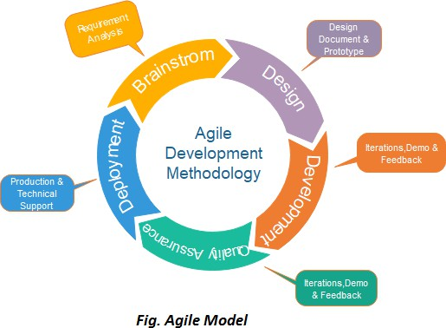

## Project Methodology

##### Scrum

* The Scrum model is well-suited for the development of this project due to its iterative and incremental nature, which aligns seamlessly with the characteristics of AI projects. In the context of content generation, where algorithms and models need fine-tuning and constant improvement, Scrum's iterative cycles, known as sprints, provide a structured framework for continuous refinement.
* The choice to use the Scrum model in this project stems from its suitability for dynamic and iterative development processes, which aligns well with the nature of creating a content craft hub platform. Scrum is known for its flexibility and adaptability to changing requirements, which is crucial in the fast-evolving landscape of AI and content creation technologies.
* In a Scrum framework, development is organized into short, time-boxed iterations called sprints. This allows the team to regularly reassess priorities, incorporate feedback, and adjust development goals. Given the complexity of integrating AI models, developing a user-friendly interface, and meeting various content generation needs, Scrum's iterative nature helps in managing uncertainties effectively.
* the Scrum model is chosen for its adaptability, iterative approach, emphasis on collaboration, and its ability to deliver incremental, high-quality results—features that are particularly beneficial in a complex project like the development of an AI-Based Content.

## Phases of Project

###### Planning Phase

* **Sprint Planning**: Define the goals and deliverables for the sprint. Break down the product backlog into sprint backlog items.
* **Requirement Gathering**: Collaborate with stakeholders to gather detailed requirements and user stories.

###### Design Phase

* **System Design**: Create the system architecture, including front-end and back-end designs, data models, and AI integrations.
* **UI/UX Design**: Develop wireframes and prototypes using tools like Adobe XD or Figma to ensure a user-friendly interface.

###### Development Phase

* **Sprint Execution**: Develop features incrementally in sprints. Each sprint includes coding, testing, and integrating new features.
* **Daily Stand-ups**: Conduct daily meetings to discuss progress, challenges, and next steps.

###### Testing Phase

* **Continuous Testing**: Perform unit testing, integration testing, and end-to-end testing within each sprint.
* **Feedback Integration**: Gather feedback from stakeholders and users at the end of each sprint and incorporate it into the next cycle.

###### Review and Retrospective Phase

* **Sprint Review**: Demonstrate the increment to stakeholders and gather feedback.
* **Sprint Retrospective**: Reflect on the sprint process to identify what went well and what can be improved in the next sprint.

###### Deployment Phase

* **Staging Environment**: Deploy the application to a staging environment for final testing.
* **Production Deployment**: After successful testing, deploy the application to the production environment.

###### Maintenance Phase

* **Monitoring**: Continuously monitor the application for performance and reliability.
* **Updates and Improvements**: Regularly update the application based on user feedback and emerging technologies.

**Phases Of Project**:

|  |  |  |  |  |
| --- | --- | --- | --- | --- |
| **No.** | **Phases** | **Duration** | **Action Performed** | **Responsible Person** |
| 1 | **Project Planning** | 20 Days | Objective setting, TimeLine development &  scope of project | Ahmed Ali |
| 2 | **Resource Planning** | 25 Days | Technological Resources, Financial Resources  &  Document Resource | Syed Daniyal Ali |
| 3 | **Requirement Analysis** | 20 Days | Functional &  System Analysis | Syed Daniyal Ali & Ahmed Ali |
| 4 | **Designing** | 28 Days | UI/UX, Information Architecture &  Flow of project | Ali Ahmed & Syed Daniyal Ali |
| 5 | **Development** | 40 Days | Front-End | Syed Daniyal Ali & Ali Ahmed |
| 6 | **Documentation** | 15 | Report & PPT | Ali Ahmed |

## Software/Tools that Used in Project

These technologies and tools collectively enable the development team to create a robust, visually appealing, and user-friendly front end for this Software platform.

**Development Tools**: Visual Studio Code for coding, Visual Studio Code (VS Code) serves as a crucial tool in the development of this project and Android app used for emulator.

**React Native local Server:** An essential software requirement tool for running the AI-Based Content Generator.

**Design Tools**: Cascading Style sheet (CSS) for styling.

**Testing Tools**: Manual Testing during runtime.

**Communication Tools**: zoom or Microsoft Teams for team communication and collaboration.

## Hardware that Used in Project

##### Dell Laptop

* Laptop with Internet Connectivity.
* Wire Mouse.

##### System Requirements

* Operating System: Microsoft Windows 11.
* CPU Type: Intel® Core (TM) i7-4300 U CPU @2.32GHz 2.40GHz
* Memory: 8GB/ Disk Space: 256 SSD 320 HDD

**Chapter 5**

**IMPLEMENTATION**

## Proposed System Architecture/Design

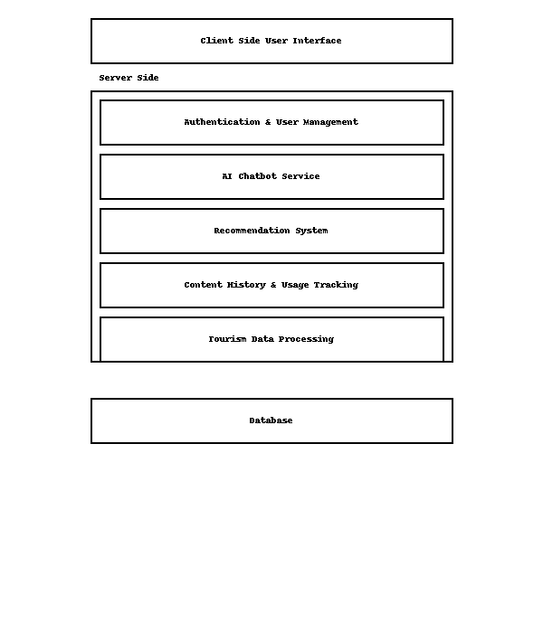

* 1. **Functional Specifications**

The Functional specifications for the platform outline the specific features and functionalities that the system will provide. Here's a list of potential functional specifications for the project:

###### User Registration and Authentication:

The system shall allow users to register using email, phone number.

The system shall authenticate users during login using their registered credentials.

###### User Profile Management:

The system shall allow users to create and update their profile with preferences, interests, and travel history.

The system shall store user preferences for personalized recommendations.

###### Destination Recommendation

The system shall analyze user preferences, current location, and historical data to recommend suitable destinations, activities, and accommodations.

The engine shall update recommendations in real time based on user interactions.

###### Destination Search and Information Retrieval

The system shall allow users to search for destinations manually.

The system shall display detailed information for each destination, including attractions, events, climate, history, and user reviews.

###### Tour and Activity Booking

The system shall enable users to browse and book tours, activities, and experiences.

###### Chatbot Guide (Virtual Tour Guide)

The system shall include an chatbot that responds to user queries regarding places, transportation, culture, safety, etc.

The chatbot shall support natural language input and provide instant, relevant responses.

## Non-Functional Specifications

Non-functional specifications for encompass aspects that are not directly related to specific features but are critical for the overall system performance, reliability, and user experience. Here are potential non-functional specifications for the project:

###### Performance Requirements:

The system shall load destination pages and recommendations within 3 seconds under standard network conditions.

The chatbot shall respond to user queries within 2 seconds on average.

The app shall support up to 100,000 concurrent users without performance degradation.

###### Reliability

The system shall maintain 99.9% uptime excluding scheduled maintenance.

In the event of a failure, the system shall automatically switch to a backup server within 30seconds.

###### Scalability

The app shall be designed to scale horizontally to support increasing numbers of users, destinations, and data points.

The User based recommendation engine shall be capable of handling increased data volume with minimal reconfiguration.

###### Security

The system shall load destination pages and recommendations within 3 seconds under standard network conditions.

###### Logging and Monitoring

The system shall maintain detailed logs of user activity, system errors, and admin actions.

Logs shall be retained for at least 6 months and monitored for unusual behaviour.

## Testing

##### Test Cases for AI Powered Tourism App

1. **User Registration**

###### Test Case 1.1: User Registration

* + **Description:** Verify that a new user can successfully register.
  + **Preconditions:** User is on the registration page.

###### Test Steps:

* + 1. Enter valid username, email, and password.
    2. Click the "Register" button.
  + **Expected Result:** User is registered and redirected to the login page with a success message.

###### Test Case 1.2: User Login

* + **Description:** Verify that a registered user can log in.
  + **Preconditions:** User is registered and on the login page.

###### Test Steps:

* + 1. Enter valid email and password.
    2. Click the "Login" button.
  + **Expected Result:** User is logged in and redirected to the dashboard.

###### Test Case 1.3: Invalid Login Attempt

* + **Description:** Verify that an error message is displayed for invalid login credentials.
  + **Preconditions:** User is on the login page.

###### Test Steps:

* + 1. Enter invalid email or password.
    2. Click the "Login" button.
  + **Expected Result:** Error message "Invalid email or password" is display

#### User Dashboard

###### Test Case 4.1: View User Dashboard

* + **Description:** Verify that the user can view their dashboard with relevant information.
  + **Preconditions:** User is logged in and on the dashboard page.

###### Test Steps:

* + 1. Navigate to the dashboard page.
  + **Expected Result:** User's dashboard with relevant information (e.g., recent activities) is displayed.

###### Test Case 4.2: Edit Profile Information

* + **Description:** Verify that the user can edit their profile information.
  + **Preconditions:** User is logged in and on the profile edit page.

###### Test Steps:

* + 1. Navigate to the profile edit page.
    2. Edit the necessary profile information.
    3. Click the "Save" button.
  + **Expected Result:** Profile information is updated and a success message is displayed.

#### Admin Dashboard

###### Test Case 5.1: Admin Login

* + **Description:** Verify that an admin can log in to the admin dashboard.
  + **Preconditions:** Admin is on the admin login page.

###### Test Steps:

* + 1. Enter valid admin credentials.
    2. Click the "Login" button.
  + **Expected Result:** Admin is logged in and redirected to the admin dashboard.

###### Test Case 5.2: Manage Users

* + **Description:** Verify that the admin can view and manage user accounts.
  + **Preconditions:** Admin is logged in and on the user management page.

###### Test Steps:

* + 1. Navigate to the user management page.
  + **Expected Result:** Admin can view, edit, and delete user accounts.

These test cases cover various functionalities of the Content Crafting Hub project, ensuring that all critical aspects of the platform are thoroughly tested.

## Purpose of Testing

Testing is a critical phase in the development of the AI Powered Tourism App, serving multiple purposes to ensure the platform's quality, reliability, and user satisfaction. Here are the key purposes of testing in this project:

1. **Ensuring Functionality**: Testing verifies that all features and functionalities of the AI Powered Tourism App work as intended. This includes user interactions, data processing, and integration of various APIs. Functional testing ensures that the platform meets the specified requirements and performs its tasks correctly.
2. **Detecting and Fixing Bugs**: During testing, any defects, errors, or bugs are identified. This is crucial for maintaining the integrity of the software. Early detection of issues allows developers to address and fix them before the final release, reducing the likelihood of encountering critical problems in production.
3. **Improving Performance**: Performance testing assesses the system's behavior under different conditions, such as varying loads and stress levels. This helps ensure that the platform can handle high traffic and large volumes of data efficiently without compromising speed or responsiveness.
4. **Enhancing Security**: Security testing is conducted to identify vulnerabilities and ensure that the platform is protected against threats and attacks. This includes testing for data breaches, unauthorized access, and other security risks to safeguard user information and maintain trust.
5. **Validating User Experience**: Usability testing focuses on the user interface and overall user experience. It ensures that the platform is intuitive, easy to navigate, and meets the users' needs. Positive user experience is critical for the adoption and success of the platform.
6. **Ensuring Compatibility**: Compatibility testing verifies that the AI Powered Tourism App works seamlessly across different devices, and operating systems. This is essential to provide a consistent experience for all users, regardless of how they access the platform.
7. **Compliance with Standards**: Testing ensures that the platform complies with industry standards, regulations, and best practices. This includes accessibility standards, data protection regulations, and coding standards.
8. **Facilitating Maintenance and Scalability**: Well-tested software is easier to maintain and scale. Testing helps ensure that the codebase is robust and adaptable, allowing for future enhancements, updates, and scalability without introducing new issues.

By conducting thorough testing, the development team can deliver a high-quality, reliable, and secure AI Powered Tourism that meets user expectations and stands out in the competitive market.

* 1. **Test Cases**

|  |  |  |  |  |  |
| --- | --- | --- | --- | --- | --- |
| Test Case ID | Test Case Description | Preconditions | Expected Result | Actual Result | Status |
| TC-01 | Verify user login functionality | User is registered and has valid credentials | User should be redirected to the home screen/dashboard | User is redirected to the home screen/dashboard | Pass |
| TC-02 | Verify user registration functionality | User is not registered | User should receive a confirmation email and be able to log in | User receives confirmation email and can log in | Pass |
| TC-03 | Verify AI destination recommendation generation | User is logged in and has set preferences | AI should generate and display personalized destination recommendations | AI generates and displays personalized destination recommendations | Pass |
| TC-04 | Verify destination information display | User is logged in | The platform should display detailed information for the selected destination | Destination information is displayed | Pass |
| TC-05 | Verify AI chatbot assistant functionality | User is logged in | AI chatbot should respond to user queries related to travel and destinations | AI chatbot responds accurately to user queries | Pass |
| TC-06 | Verify tour/activity booking functionality | User is logged in | User should be able to book an activity and receive confirmation | Activity is booked and confirmation is received | Pass |
| TC-07 | Verify admin content management access | Admin user is logged in | Admin should be able to view, add, edit, or delete destination and event data | Admin can view, add, edit, and delete content | Pass |
| TC-08 | Verify personalized itinerary generation | User is logged in and has selected preferences | The system should create a day-by-day itinerary based on selected options | Itinerary is generated and displayed | Pass |

**Chapter 6**

**EXPERIMENTAL EVALUATIONS & RESULTS**

**Evaluation Testbed**

The evaluation testbed for the **AI-powered Tourism App** consists of several components aimed at assessing its **performance, reliability, usability**, and **feature accuracy**. These evaluations help ensure the application delivers a seamless experience to travelers and tourists while meeting both technical and user-centered standards. The testbed includes the following key elements:

1. Performance Metrics: The performance of the AI-powered Tourism App is evaluated using key metrics such as:

Response time for recommendations and content loading

Throughput in terms of number of users served per second

Resource utilization like CPU and memory usage during peak usage  
These metrics determine how efficiently the system performs and scales under varying loads, ensuring consistent service even during high demand (e.g., tourist season).

1. Functional Testing: Functional testing was carried out to verify that all features of the app aligned with the specified requirements. This included testing core modules like user registration and login, destination recommendations, travel itinerary planning, activity bookings, and the integrated chatbot assistant. Each component was validated independently as well as within the complete user workflow to confirm full functional integrity.
2. Usability Testing: focused on evaluating the app’s user interface and overall user experience. Test participants were asked to perform common tasks, such as finding destinations and booking tours, and their feedback was collected regarding the app’s ease of use, navigation, clarity, and visual appeal. The input received helped refine the interface to better meet the expectations of both tech-savvy and non-technical users.
3. Security Testing: played a vital role in identifying and mitigating vulnerabilities within the platform. This involved testing authentication mechanisms, enforcing strict access controls, and ensuring data privacy through encryption. The system was also examined for resilience against common attacks such as SQL injection and cross-site scripting (XSS), as well as more sophisticated threats like session hijacking.
4. Compatibility Testing: ensured the app functioned seamlessly across a wide range of platforms and devices, including Android and iOS smartphones, tablets, and desktop environments. The application was tested on popular browsers like Chrome, Safari, Firefox, and Edge, as well as across various screen sizes and resolutions, to guarantee consistent performance and visual presentation.
5. Accessibility Testing: Accessibility testing was conducted to ensure the app could be used by individuals with disabilities. This included verifying screen reader compatibility, keyboard navigation, appropriate color contrast, and overall compliance with international accessibility standards such as the Web Content Accessibility Guidelines (WCAG). These measures were critical in ensuring inclusivity for all user groups.
6. Load and Stress Testing: Simulated high-demand scenarios, such as when a large number of users access the app simultaneously during a major event or travel season. These tests helped identify performance bottlenecks and guided the optimization of backend systems to ensure stability, even under extreme conditions.
7. End-to-End Testing: testing was performed to validate the app’s entire workflow from start to finish. This involved testing the complete journey of a user—from logging in, receiving personalized AI recommendations, creating an itinerary, and booking activities, to finally logging out. This comprehensive testing confirmed that all interconnected components functioned reliably and cohesively across different user paths.

In conclusion, the evaluation testbed for the AI-powered Tourism App provided a thorough and systematic approach to testing every aspect of the platform. Through performance, functionality, usability, security, compatibility, and accessibility assessments, the app was refined and validated to meet both technical standards and user expectations, ensuring a successful deployment and user satisfaction.

## Results and Discussion

The results obtained from the evaluation testbed provided critical insights into the performance, functionality, usability, security, compatibility, accessibility, and scalability of the AI-powered Tourism App. These findings highlight the app's readiness for real-world deployment and its effectiveness in delivering intelligent travel services to users.

Performance: In terms of performance, the app showed excellent responsiveness and efficiency. During testing, the system maintained low response times and high throughput, even under varying loads, including simulated peak travel seasons. Resource utilization remained within optimal limits, ensuring that the app could operate smoothly and reliably during high-demand periods without lags or slowdowns.

Functionality: Functionality testing confirmed that the application met all defined requirements and delivered expected outputs. Core features such as destination recommendations, itinerary planning, and travel assistant interaction performed accurately. The system also integrated seamlessly with third-party APIs, including mapping, translation, and booking services, which contributed to a smooth and consistent user experience. Any issues discovered during this phase were promptly resolved through iterative testing and refinement.

Usability: Usability testing revealed that users found the app intuitive and easy to navigate. Test participants appreciated the logical flow of the user interface, the clarity of design elements, and the responsiveness of interactive features. The particularly praised for providing relevant suggestions and simplifying travel planning tasks, which significantly enhanced the overall user experience.

Security: Security testing was conducted to ensure the protection of user data and application integrity. Potential vulnerabilities were successfully identified and mitigated. Security measures such as robust encryption, user authentication, and access control mechanisms were implemented, providing users with a secure environment to manage their travel information and personal data.

Compatibility: The compatibility of the app was also thoroughly validated. It functioned consistently across multiple platforms including Android, iOS, and web browsers like Chrome, Firefox, Safari, and Edge. Regardless of the device or screen size, users were able to access all functionalities without any disruptions, ensuring a wide reach and accessibility.

Accessibility testing: Usability Accessibility testing further demonstrated the app’s inclusivity. Features such as screen reader support, keyboard navigation, and appropriate color contrasts were tested and optimized to comply with accessibility standards. This made the application usable for individuals with various disabilities, thus enhancing its user base and societal value.

During load and stress testing: The application was subjected to high user volumes and resource-intensive operations. The results showed that the system could handle such conditions without crashing or significant performance drops. Scalability features built into the backend infrastructure allowed the app to adapt dynamically to increased usage demands, making it suitable for nationwide or international tourist audiences.

End-to-end testing: Validated that all components of the application worked together seamlessly throughout the entire user workflow. From signing up and receiving travel recommendations to booking tours and managing itineraries, every module integrated correctly and functioned as intended. This end-to-end validation reinforced the app's reliability in delivering a complete and coherent user experience

In conclusion, the AI-powered Tourism App successfully met all quality standards and user expectations through rigorous evaluation. Its strong performance, rich functionality, user-friendly design, and robust security features position it as a reliable and innovative travel companion. Continuous monitoring and iterative enhancements will ensure the app remains aligned with evolving user needs and technological advancements in AI and tourism services.

## CHAPTER 7 CONCLUSION AND DISCUSSION

* 1. **Strength of this Project**

**Comprehensive Travel Solution**: The AI-powered Tourism App serves as a unified platform offering a wide array of travel-related services, such as destination recommendations, itinerary planning, tour booking and local cultural insights. This integration minimizes the need for users to use multiple applications, saving them time and simplifying the entire travel experience.

**User-Centric Interface:** Designed with a strong emphasis on UI/UX, the app features an intuitive and visually appealing interface. Whether the user is tech-savvy or a novice traveler, the clean and organized layout ensures effortless navigation and interaction.

**Scalable and Adaptable Architecture:** The platform is built with scalability in mind, capable of handling a growing user base without compromising performance. Its adaptable design allows for easy integration of future features such as hotel bookings, AR-guided tours, and expanded language support.

**Cost-Effective Travel Companion:** By offering a wide range of travel services in one platform, the app eliminates the need for users to rely on multiple paid tools or travel agents. This cost-effective model is beneficial for both individual travelers and businesses in the tourism industry.

**Improved Efficiency and Planning:** The app enhances user productivity by automating the planning process through intelligent itinerary generation and route optimization. This allows users to make informed travel decisions quickly, saving hours of manual research and coordination.

**Versatile Use Cases:** The platform is designed to cater to various types of users—from solo travelers and families to travel agencies and tour guides. Its wide range of supported features makes it suitable for leisure, business, and educational travel purposes.

**Continuous Improvement Approach:** Built using the Agile methodology with Scrum practices, the project follows an iterative development cycle with continuous feedback from users. This ensures that the app remains responsive to user needs, market changes, and evolving technological trends.

**Robust Infrastructure:** The backend of the application is developed using secure, high-performance, and scalable technologies. This ensures high availability, data security, and consistent system performance under all conditions.

**Comprehensive Support and Help Features:** The app includes extensive in-app support, user documentation, and a feedback mechanism. These support tools assist users in understanding the platform, solving problems, and enhancing satisfaction and retention.

**Innovative and Competitive Edge:** By combining advanced AI, real-time data, and personalized travel planning in one cohesive experience, the AI-powered Tourism App sets itself apart from traditional travel apps. Its innovative capabilities give it a strong competitive edge in the digital tourism landscape.

## Limitations

While the AI-powered Tourism App offers a wide range of benefits and intelligent functionalities for travelers, there are certain limitations that must be acknowledged to ensure a realistic understanding of its scope and challenges.

Scalability Challenges: As the user base expands and more users simultaneously access, the platform may face scalability issues related to server load, data storage, and response times. Ensuring that the backend infrastructure can scale effectively is necessary to maintain performance during peak travel seasons or promotional campaigns.

Privacy and Security Concerns: Since the app collects and processes user data such as location, travel history, and preferences, there are inherent risks regarding privacy and data security. It is crucial to implement robust security protocols, encryption, and access controls to safeguard sensitive information and prevent data breaches or unauthorized access.

User Learning Curve: Some users, especially those unfamiliar travel tools, may initially find it challenging to understand and fully utilize the app’s features. This could impact user adoption and satisfaction. Therefore, offering comprehensive tutorials, tooltips, and responsive customer support will be essential to help users become comfortable with the platform. By recognizing these limitations and addressing them proactively through strong development practices, user education, and infrastructure planning, the AI-powered Tourism App can continue to evolve into a more robust, secure and user friend

## REFERENCES

1. <https://startups.epam.com/blog/artificial-intelligence-in-tourism-and-travel-industry>
2. <https://startups.epam.com/blog/artificial-intelligence-in-tourism-and-travel-industry>
3. <https://1xmarketing.com/news/en/world-marketing-diary-240820112102/>
4. <https://1xmarketing.com/news/en/world-marketing-diary-240820111734/>
5. <https://1xmarketing.com/news/en/world-marketing-diary-240820111734/>
6. <https://www.paradigmshift.com.pk/tafreego-pakistan/>
7. <https://mofa.gov.pk/meet-pakistan-app>
8. <https://kodytechnolab.com/blog/travel-app-ideas/>

**APPENDICES**

**A0. Copy of Project Registration Form**

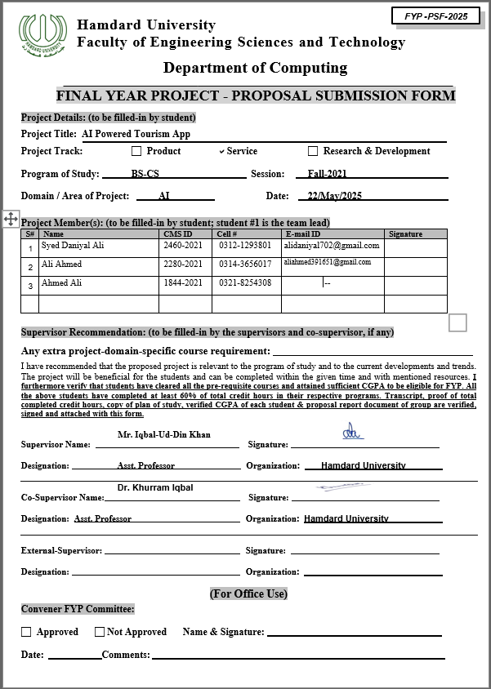

**A1a. Project Proposal and Vision Document**

## Chapter 1

## Introduction

We are introducing an AI-Powered Tourism App, an innovative solution that harnesses the capabilities to transform the way users explore travel destinations. This intelligent application offers a suite of user-centric features designed to enhance the tourism experience by providing smart recommendations, interactive travel assistance through chatbot, and real-time access to destination-specific information.

Tailored for travelers, tour planners, tourism agencies, and enthusiasts, the app delivers personalized travel suggestions based on user preferences, interests, and current trends. The integrated chatbot acts as a virtual travel assistant—answering queries, suggesting activities, and guiding users through their travel planning journey.

Additionally, the app includes a smart recommendation system that suggests places to visit, restaurants to try, and activities to explore based on user history and preferences. With a focus on usability, the application features a clean and intuitive interface, ensuring that users of all backgrounds can navigate and interact with the system effortlessly.

Supported by a robust backend infrastructure and modern technologies, the AI-Powered Tourism App provides a seamless and intelligent travel experience, elevating how users discover and enjoy new destinations

## Motivation

The AI-Powered Tourism App addresses the challenges of time-consuming and overwhelming travel planning by offering user based recommendations, automated itineraries, and real-time information. By leveraging the app simplifies travel planning, empowers users to explore confidently, and highlights the transformative potential.

## Problem Statement

Travelers exploring Pakistan encounter diverse challenges, from navigating unfamiliar regions to customizing their experiences a wealth of options. An AI Powered tourism app tackles these complexities by harnessing sophisticated algorithms to deliver personalized recommendations, streamline itinerary planning, and offer real-time insights. By enhancing accessibility, improving convenience, and fostering cultural appreciation, this technology not only enriches travel experiences but also contributes to a more inclusive and vibrant tourism landscape in Pakistan.

## Goals and Objectives

User-Friendly Interface: Design an intuitive and responsive interface that enhances user interaction and accessibility, making travel planning and navigation seamless and enjoyable. Chatbot Integration: Implement a conversational chatbot capable of understanding user queries, providing user base recommendations, assisting with bookings, and offering real-time support throughout the journey. Trip Recommendations by User Interest: Utilize Recommendation algorithms to analyze user preferences, past travel behaviour, and demographic data to suggest personalized trip itineraries, including attractions, activities, and dining options aligned with user interests.

## Project Scope

AI-powered tourism application focused on enhancing user travel experiences through user base recommendations, travel planning, and real-time updates. The scope of this project explicitly defines what aspects will and will not be considered, along with key assumptions guiding system evolution.

## Chapter 2 Feasibility Study

* 1. **Introduction**

The inception of this platform is to marks a transformative venture in the realm of content creation, harnessing the prowess of cutting-edge technologies. As we embark on this innovative journey, a comprehensive feasibility study stands as a pivotal precursor to ascertain the project's viability. This study, encompassing technical, economic, legal, operational, and market perspectives, casts an optimistic light on the prospect of the platform. The amalgamation of robust technical capabilities, economic soundness, legal adherence, operational scalability, punctual development timelines, market resonance, and adept risk mitigation strategies collectively underscores the feasibility and potential success of this groundbreaking project.

## Risk Involved

Developing this project involves navigating various risks across technical, data, user adoption, market, and project management domains.

* + - Technical challenges, such as algorithmic complexity and integration issues, require a careful allocation of time for research and testing.
    - Data risks, including concerns about quality, availability, and privacy, necessitate measures like ensuring access to diverse, high-quality data and implementing robust security protocols.
    - User acceptance and adoption risks, such as resistance to AI solutions and potential user experience issues and continuous user feedback.
    - Market risks, tied to competition and evolving client needs, call for differentiation through unique features, ongoing competition monitoring, and adaptability to changing demands.
    - Project management risks, such as resource constraints and scope creep, can be mitigated through thorough resource planning, outsourcing consideration, and a robust change management process.

Early identification and proactive mitigation of these risks, coupled with regular assessments and effective communication, are vital for the project's successful execution.

## Resource Requirement:

In the front-end development phase of this project, a proficient team of Front-End Developers collaborates with UI/UX Designers to ensure a seamless fusion of functionality and design. Leveraging expertise in HTML, CSS, JavaScript, and React Native this team employs high-performance development machines to meet computational demands. Essential software tools like Visual Studio Code.

## Solution Application Areas

* + - From the intricacies of digital marketing, where it refines blog posts and social media captions to elevate strategies, to the realm of e-commerce, enhancing product descriptions and driving sales, the platform demonstrates versatility.
    - Its impact extends to publishing and media, streamlining content creation for news articles and blog posts, while also supporting SEO agencies in optimizing content for search engines it becomes an integral tool for regular blog posts and marketing content, facilitating customer engagement.
    - The platform's capabilities address global content needs, supporting social media managers, content agencies, bloggers, and creators in crafting diverse and high quality content. Its adaptability to cross-industry content needs positions it as a comprehensive solution, redefining content creation across diverse sectors.

## Chapter 3 Methodology

* 1. **Project Approach**

##### Agile

The decision to adopt an Agile approach for the development of this project is grounded in its alignment with the dynamic and iterative nature of App based AI projects. The Agile methodology, with its core principles of flexibility, client collaboration, and incremental development, is particularly well-suited for endeavors where requirements are subject to change and continuous improvement is essential.

In the realm of AI, which often involves intricate algorithms and evolving technologies, the Agile framework allows for regular adjustments based on emerging insights, changing priorities, and client feedback.

the Agile approach is a strategic choice to navigate the complexities of AI content generation, fostering innovation, responsiveness, and a client-centric development process.

the Agile approach is chosen for its adaptability, iterative nature, focus on user satisfaction, collaborative environment, risk mitigation, continuous improvement, and efficiency in delivering a product to the market. All these aspects make it well-suited for the development of this project.

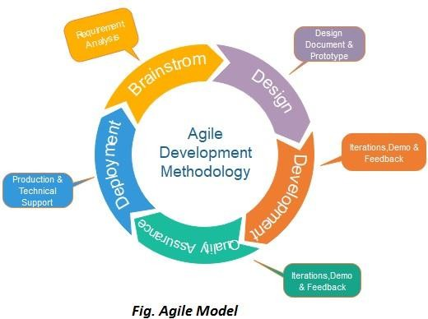

##### Scrum

* The Scrum model is well-suited for the development of t this project due to its iterative and incremental nature, which aligns seamlessly with the characteristics of AI projects. In the context of content generation, where algorithms and models need fine-tuning and constant improvement, Scrum's iterative cycles, known as sprints, provide a structured framework for continuous refinement.
* The choice to use the Scrum model in this project stems from its suitability for dynamic and iterative development processes, which aligns well with the nature of creating a AI Powered Tourism App platform. Scrum is known for its flexibility and adaptability to changing requirements, which is crucial in the fast-evolving landscape of AI and content creation technologies.
* In a Scrum framework, development is organized into short, time-boxed iterations called sprints. This allows the team to regularly reassess priorities, incorporate feedback, and adjust development goals. Given the complexity of integrating AI models, developing a user-friendly interface, and meeting various content generation needs, Scrum's iterative nature helps in managing uncertainties effectively.
* The Scrum model is chosen for its adaptability, iterative approach, emphasis on collaboration, and its ability to deliver incremental, high-quality results—features that are particularly beneficial in a complex project like the development of an AI-Based.

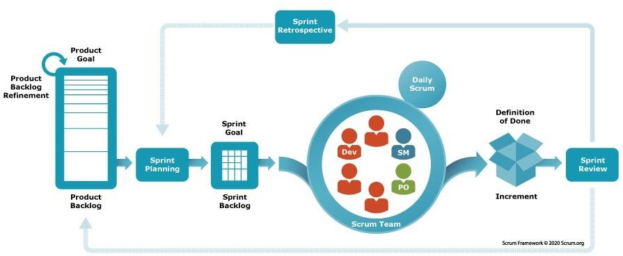

## Phases/Sprints of Project

|  |  |  |  |  |
| --- | --- | --- | --- | --- |
| **No.** | **Phases** | **Duration** | **Action Performed** | **Responsible Person** |
| 1 | **Project Planning** | 20 Days | Objective setting, TimeLine development &  scope of project | Ahmed Ali |
| 2 | **Resource Planning** | 25 Days | Technological Resources, Financial Resources  &  Document Resource | Syed Daniyal Ali |
| 3 | **Requirement Analysis** | 20 Days | Functional &  System Analysis | Syed Daniyal Ali & Ahmed Ali |
| 4 | **Designing** | 28 Days | UI/UX, Information Architecture &  Flow of project | Ali Ahmed & Syed Daniyal Ali |
| 5 | **Development** | 40 Days | Front-End | Syed Daniyal Ali & Ali Ahmed |
| 6 | **Documentation** | 15 Days | Report & PPT | Ali Ahmed |

Table 3.2: Phases of Project

* + 1. **Ghant Chart**

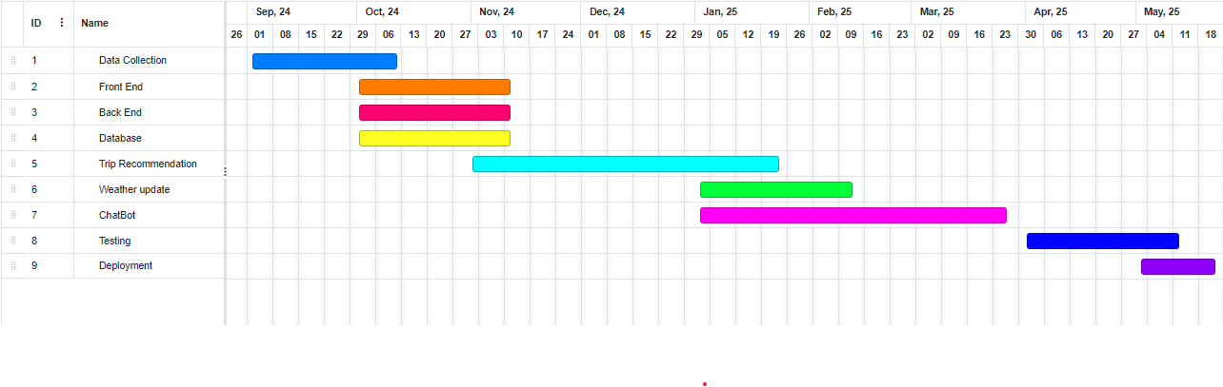

## Project Requirements

* + 1. **Software tool and Technology Requirements**

# React Native local Server

For the development and deployment of the AI-Powered Tourism App, a local React Native server serves as a critical software environment. React Native, a popular open-source framework developed by Meta, allows for efficient cross-platform mobile app development using JavaScript and React. The local server enables real-time testing, debugging, and rendering of the app on both Android and iOS devices during development.

The platform’s frontend is built using React Native to ensure a responsive and user-friendly mobile interface. The local development server facilitates rapid iteration, hot reloading, and seamless integration of app components, improving development efficiency and user experience.

# Visual Studio Code

Visual Studio Code (VS Code) serves as a crucial tool in the development of this project for several reasons:

**Compatibility:** HTML is universally supported by web browsers, ensuring that content structured with HTML can be rendered consistently across different platforms and devices. This compatibility is essential for reaching a broad user base and ensuring a seamless user experience.

**Cross-Platform Compatibility:** VS Code is compatible with Windows, macOS, and Linux, ensuring a consistent development experience across different operating systems. This flexibility is essential for a diverse development team that may use different platforms.

**Integrated Development Environment:** VS Code provides a rich set of features typical of a full-fledged IDE. These features include syntax highlighting, completion, and debugging tools, creating an integrated and efficient environment for developers. This is particularly valuable in a project with multiple components like AI algorithms, UI design, and front-end development. **Extensions:** VS Code supports a vast array of extensions, allowing developers to tailor the

editor to their specific needs. Extensions for various programming languages, version control systems, and integrated terminals enhance functionality and cater to the diverse requirements of the project.

**Version Control Integration:** VS Code seamlessly integrates with version control systems like Git. This is crucial for collaborative development, enabling multiple developers to work on the project simultaneously while keeping track of changes, ensuring code integrity, and facilitating efficient collaboration.

**Debugger:** The built-in debugger in VS Code simplifies the process of identifying and fixing issues in the code. This enhances the overall code quality and expedites the development and debugging process.

**User-Friendly Interface:** VS Code boasts a clean and intuitive interface, making it accessible to developers with varying levels of experience. The user-friendly nature of the IDE contributes to a smooth coding experience, increasing overall development efficiency. **Customization:** VS Code allows users to customize their development environment by adjusting themes, preferences, and key bindings. This flexibility ensures that developers can tailor the environment to suit their individual preferences and work efficiently.

**Community Support:** Being a widely used and popular code editor, VS Code has a large and active community. This means a wealth of resources, tutorials, and community- developed extensions, which can be invaluable for problem-solving and staying updated on best practices.

# HTML (Hypertext Markup Language):

**Compatibility:** HTML is universally supported by web browsers, ensuring that content structured with HTML can be rendered consistently across different platforms and devices. This compatibility is essential for reaching a broad user base and ensuring a seamless user experience.

**Structure and Semantics:** HTML provides a standardized way to structure content on the web. Using HTML tags like <head>, <body>, <header>, <footer>, and others, allows developers to create a clear and semantically meaningful structure for the content. This is crucial for both human readability and search engine optimization.

**Ease of Learning and Use:** HTML has a straightforward syntax and is relatively easy to learn. This simplicity contributes to a faster development process and allows developers to focus on other aspects of the project, such as styling and interactivity.

**Interactivity:** While HTML itself is not designed for creating interactive elements, it forms

the foundation upon which interactive features are built using JavaScript. By combining HTML with JavaScript, developers can create dynamic and engaging user interfaces.

**Integration with CSS:** HTML works seamlessly with CSS (Cascading Style Sheets), allowing developers to control the presentation and layout of HTML elements. This separation of content (HTML) and presentation (CSS) enhances maintainability and flexibility in design.

**Accessibility:** HTML supports accessibility features, making it possible to create web content that is usable by people with disabilities. This aligns with best practices for creating inclusive and user-friendly interfaces.

**Widespread Adoption:** HTML has been the standard markup language for web development for decades. Its widespread adoption means a wealth of resources, community support, and tools available for developers, contributing to a more efficient development process.

# CSS (Cascading Style Sheets):

**Visual Styling:** CSS provides a powerful and flexible mechanism for styling HTML elements. It allows developers to define the look and feel of the user interface, including aspects such as fonts, colors, margins, and padding. This level of control ensures a visually appealing and consistent design across the platform.

**Separation of Concerns:** CSS promotes the separation of content (HTML) and presentation (styling). This separation enhances the maintainability of the codebase, as changes to the visual design can be made in the CSS files without altering the HTML structure. It aligns with best practices in software development, facilitating a more organized and modular approach.

**Responsive Design:** CSS facilitates the implementation of responsive design principles. With features like media queries, developers can create styles that adapt to different screen sizes and devices. This is essential for ensuring a seamless user experience across a variety of platforms, including desktops, tablets, and mobile devices.

**Ease of Use:** CSS has a straightforward syntax, making it accessible to developers with varying levels of experience. Its rules-based structure allows for the efficient application of styles to specific elements or classes, contributing to a more streamlined development process.

**Browser Compatibility:** CSS is widely supported across different web browsers, ensuring

consistent styling and layout across various platforms. This broad compatibility is crucial for reaching a diverse audience and delivering a uniform user experience.

**Animation and Transitions:** CSS includes features for creating animations and transitions. This capability allows developers to enhance the user interface with subtle animations or transitions, improving overall user engagement and interaction.

**Community Support and Resources:** CSS is a standard technology in web development, and as such, it has extensive community support. There are abundant resources, tutorials, and frameworks available, making it easier for developers to leverage existing solutions and best practices.

# JavaScript:

JavaScript is selected for the front-end development of the AI-Based platform due to its versatility and capabilities in creating dynamic, interactive, and responsive user interfaces. It facilitates real-time updates, user input validation, and asynchronous communication with the server (AJAX), contributing to a seamless and engaging user experience. JavaScript's cross-browser compatibility and rich ecosystem of libraries further enhance development efficiency and ensure a consistent experience across different browsers.

# React Native:

**React Native** is utilized in the development of the AI-Powered Tourism App to streamline and enhance the user interface design and overall mobile experience. As a powerful cross-platform framework, React Native allows developers to build native mobile applications using reusable components and a single codebase for both Android and iOS. This significantly accelerates the development process while ensuring consistency in design and functionality across devices. React Native provides a rich set of UI components that are flexible and easy to customize, helping to create a visually engaging, responsive, and user-friendly interface. Its adaptability and efficiency align with the project’s goal of delivering a smooth and polished mobile experience for all users.

#### Required Hardware

##### Dell Laptop

* + - * Laptop with Internet Connectivity.
      * Wire Mouse.

##### System Requirements

* + - * Operating System: Microsoft Windows 11.
      * CPU Type: Intel® Core (TM) i7-4300 U CPU @2.32GHz 2.40GHz Memory: 8GB/ Disk Space: 120 SSD 256

## Chapter 4 System Design

This chapter is about the design of system and figures with their notations that represent our Project. It discusses about the different types of diagrams that are used in the system development process among which some of we have used in this system.

* 1. **Overall System flow of Project**

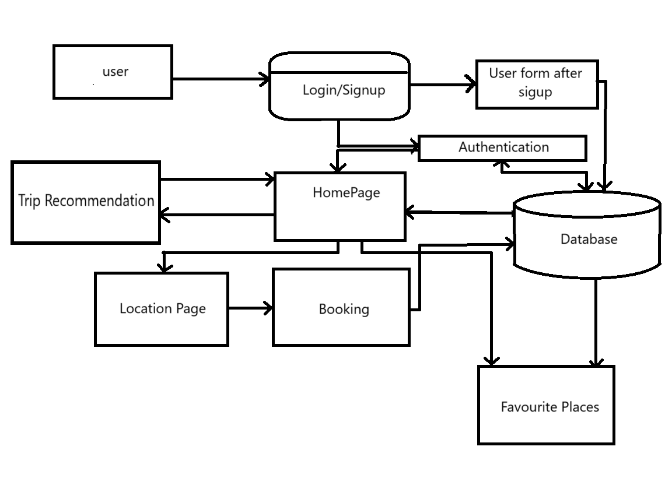

* 1. **Use Case Model**

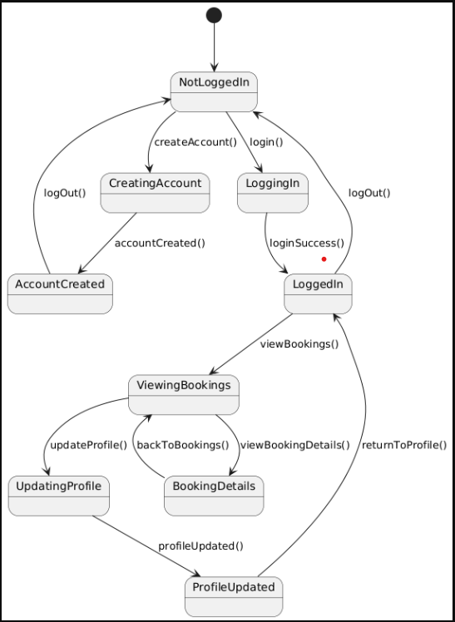

**Chapter 5**

**Project Specifications**

* 1. **Functional Specifications**

The Functional specifications for the AI-Based platform outline the specific features and functionalities that the system will provide. Here's a list of potential functional specifications for the project:

###### User Registration and Authentication:

Users can create accounts on the platform. Registration requires valid email verification. Secure login with username/password or social media authentication.

###### User Profile Management:

Users can manage their profiles, including personal information and preferences. Profile updates and password changes are supported.

###### Plain Trip:

Allowing users to make customizations. Users can preview and make adjustments before finalizing .

###### Chatbot:

Chatbot interacts with users through text-based conversations, providing instant and relevant responses based on user queries. It is programmed with predefined logic and integrated models to simulate human-like conversations. Its importance lies in offering real-time support, improving user engagement, and automating routine tasks efficiently.

###### Feedback and Improvement:

Users can provide feedback on generated content for quality improvement. System collects feedback data to enhance AI models.

###### Admin Dashboard:

Admins have access to a dashboard for user management and content moderation. Analytics on content generation and user activity are available.

These functional specifications cover the core features of the platform, ensuring a comprehensive and user-friendly experience for users. Each specification contributes to the overall goal of providing an efficient, secure, and innovative.

## Non-Functional Specifications

Non-functional specifications for the platform encompass aspects that are not directly related to specific features but are critical for the overall system performance, reliability, and user experience. Here are potential non- functional specifications for the project:

###### Performance:

* Response Time: The app should deliver swift responses, and recommendations within a few seconds to ensure a seamless user experience.
* Scalability: The system must efficiently handle increasing user loads, maintaining smooth performance even during peak usage times.
* Throughput: Support a high volume of simultaneous content generation requests without compromising performance.

###### Reliability:

* Uptime: Strive for high availability, targeting 99.9% uptime to ensure continuous access for users.
* Fault Tolerance: The system should gracefully handle errors and interruptions, preventing data loss and maintaining service continuity.

###### Security:

* Data Encryption: Implement robust encryption protocols to secure user data during transmission and storage.
* Access Control: Enforce strict access controls, ensuring users can only access authorized content and features.
* Authentication and Authorization: Utilize secure authentication mechanisms and role-based authorization to manage user access effectively

###### Usability:

* User Interface (UI): Design a user-friendly and intuitive interface accommodating users with varying technical backgrounds.
* Accessibility: Ensure the app is accessible to users with disabilities, complying with relevant accessibility standards.

###### Compatibility:

* Cross-Browser Compatibility: The app should function consistently across different mobile platforms, including Android and iOS.
* Device Compatibility: Ensure responsiveness and compatibility with various devices, including smartphones and tablets.

###### Cost:

* Cost-Efficiency: Optimize resource usage to minimize operational costs.

These requirements are designed to ensure that our AI-Powered Tourism App delivers a reliable, secure, and user-friendly experience across various devices and usage scenarios.

**Chapter 6**

**Working of Project (First Deliverables)**

* 1. **Project Front End**

The front-end development phase of the project focused on creating the user interface and overall visual experience for the users. This crucial phase involved designing and implementing the interactive elements that users will engage with.

##### User Interface Design

The team began by designing the layout, structure, and visual elements of the platform. This includes creating wireframes and mockups to plan the placement of buttons, menus, and other interactive components.

##### Prototyping

Prototypes were developed to provide a tangible representation of the user interface. This step allows for early testing and feedback, ensuring that the design aligns with user expectations and usability standards.

##### Implementation with HTML/CSS/JavaScript

The actual coding of the user interface was done using a combination of HTML for structure, CSS for styling, and JavaScript for dynamic and interactive elements. This trio ensures a responsive and visually appealing user interface.

##### Responsive Design

With the increasing use of various devices, the front-end was designed to be responsive, adapting to different screen sizes. This responsiveness ensures a positive user experience on tablets, and mobile devices.

## Features Delivered

In the initial phase of our project, we focused on developing key components of the front end to create a cohesive and user-friendly interface. Our achievements for the first FYP evaluation include:

##### Signup Page/ Login Page:

Designed and implemented an engaging and informative Signup or Login Page that provides users Information with respective to the AI Powered Tourism App.

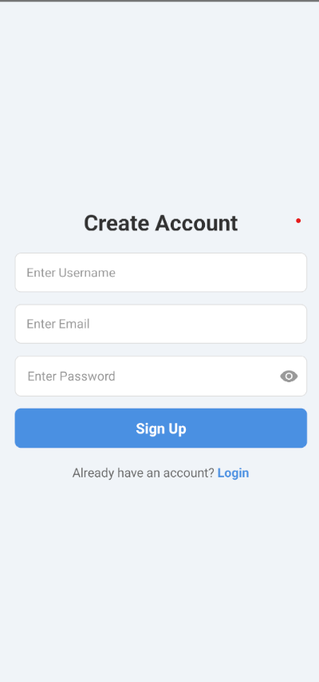

##### App Interface:

Developed a user friendly interface where users starts their journey with the AI Powered Tourism App.

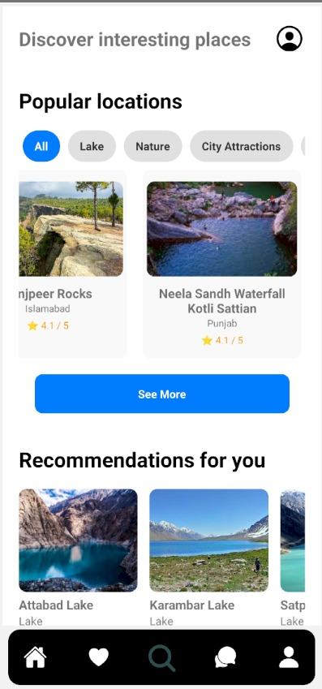

##### Users Dashboard:

Developed a user dashboard where user can manage their profile edit, delete or handle their private information.

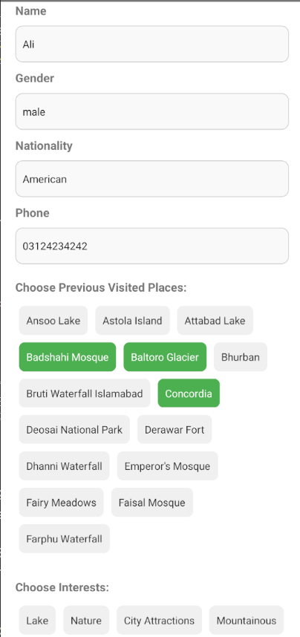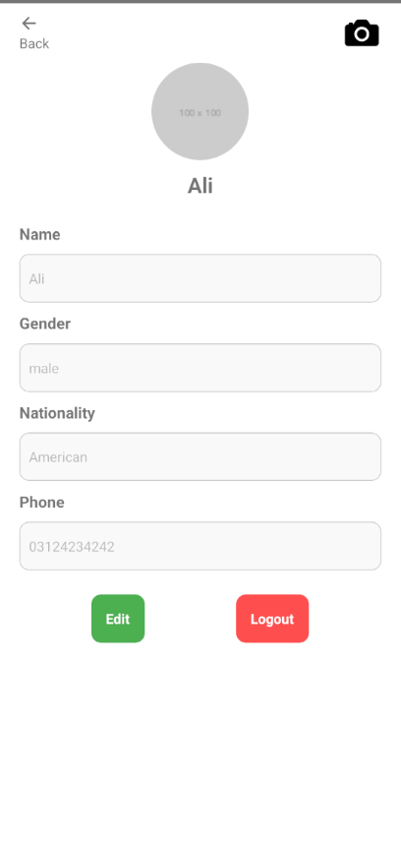

##### Favorite Places:

Implemented a section called Favorite places that enables users to select their favorite place so the user can easily select or visit.

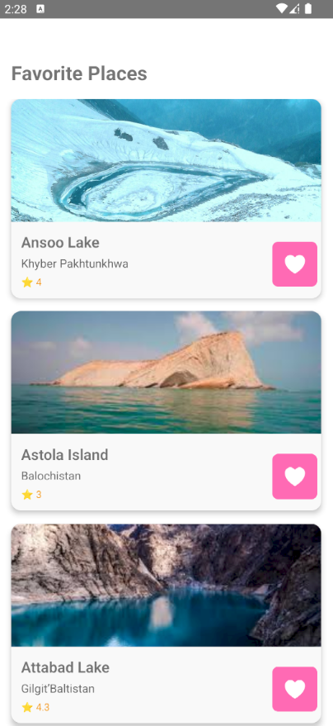

##### Filter or sort :

Developed a section Filter or sort, empowering users to easily Filter that place with the help of sorting or unsorting order.

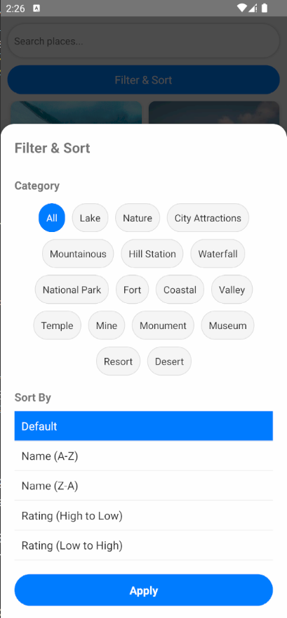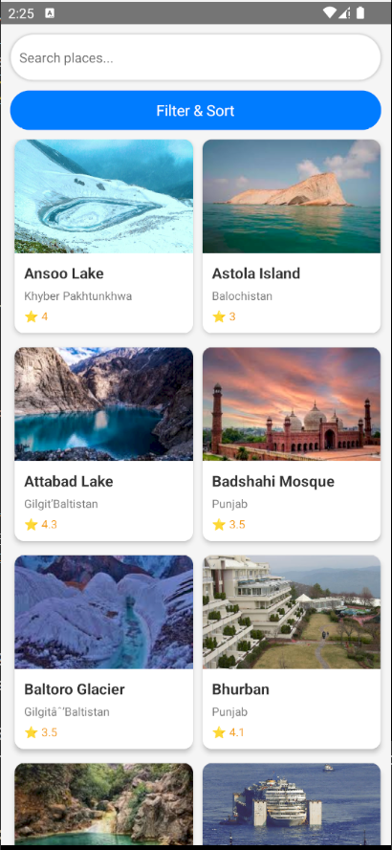

* + 1. **Admin Dashboard:**

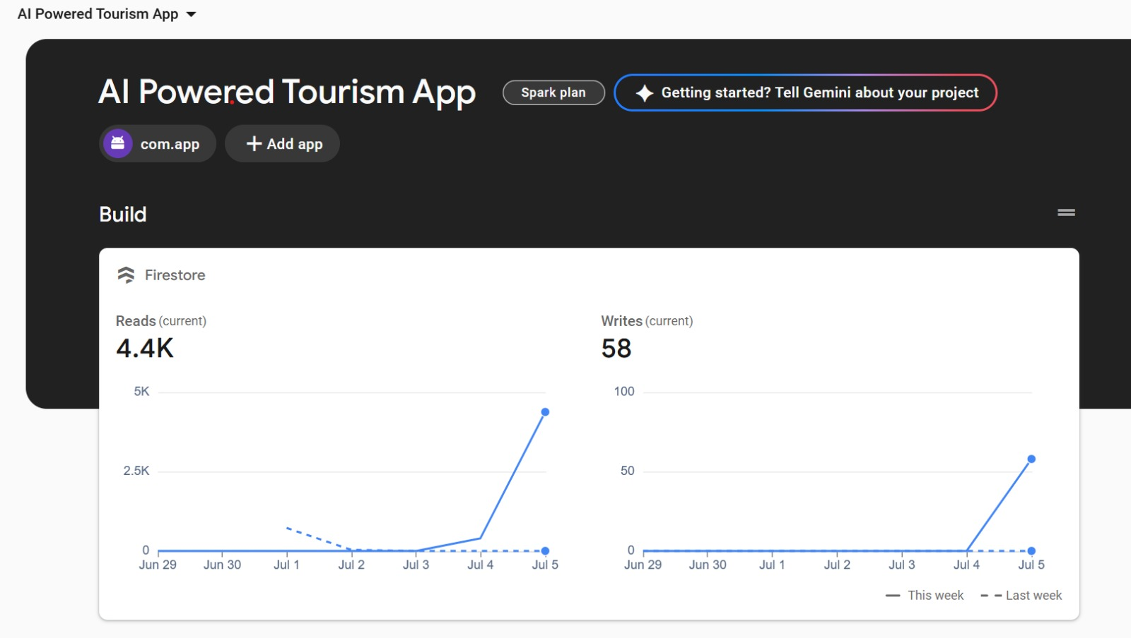

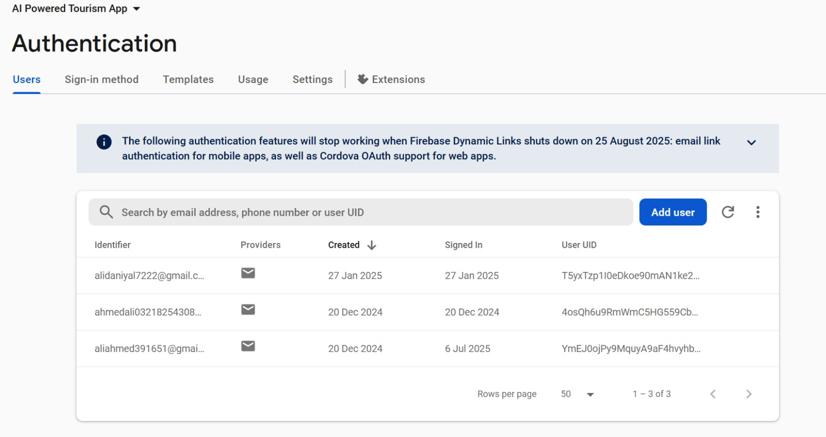

## Chapter 7 Conclusion

## Strength of this Project

The strength of the platform lies in its multifaceted capabilities, leveraging advanced technologies and innovative features. Here are the key strengths of the project:

##### Ease of Use:

A well-designed and intuitive user interface ensures that users, ranging from marketers to programmers, can easily navigate and utilize the platform without extensive training.

##### Efficient and Cost Effective:

By automating Recommendation System, the platform streamlines workflows, saving time and effort for users. This efficiency contributes to a cost-effective alternative compared to manual.

##### Basics AI Technologies:

Integrating Basics AI technologies through React Native and Firebase empowers our AI-Powered Tourism App to deliver intelligent, real-time interactions. By leveraging Firebase's robust backend services and React Native's cross-platform capabilities, the app facilitates seamless communication between users and the chatbot, enhancing user engagement and providing personalized travel experiences.

## Problems Encountered

The AI-Powered Tourism App aims to enhance travel experiences through features like user base recommendations and real-time chatbot assistance. However, challenges have emerged in maintaining consistent user engagement, ensuring the accuracy. Additionally safeguarding user data and addressing privacy concerns are critical to building and maintaining user trust. Overcoming these challenges is essential to deliver a reliable, secure, and user-friendly application.

## Conclusion

The AI-Powered Tourism App leverages advanced technologies to enhance travel experiences through user base recommendations and real-time chatbot assistance. While challenges such as maintaining user engagement, ensuring data accuracy, seamless and safeguarding user privacy have been identified, addressing these issues is crucial for delivering a reliable and user-friendly application. Continued refinement and user-centric development will be key to the app's success in the competitive travel industry.

**A1b. Copy of Proposal Evaluation Comments by Jury**

**Jury:**

**Dr. Osama Ahmed Khan**

**Dr. Farooq Iqbal**

**Mr. Saad Akbar**

**Remarks:**

**"Reduce the number of functions and narrow the scope of your algorithms to keep them simple due to limited time."**

**A2. Requirement Specifications**

1. **Introduction**
   1. **Purpose of Document:**

This Software Requirements Specification (SRS) document outlines the functional and non-functional requirements that guide the development of the AI-Powered Tourism App. It serves as a guide for the development and testing of the system

## Overall System Description

* 1. **Project Background**

In With this booming tourist industry in Pakistan, there is a demand for better solutions around traveling. The old-school process of trip planning and routing is rarely personalized or efficient. This is where the AI-Powered Tourism App comes in, utilizing the power to offer travelers user base recommendations, real-time information, and smooth navigation to their destination. In order to simplify travel planning and improve user engagement — and offer a modern solution for discovering and exploring. The app will change the way users travel, and will make it beyond easy.

## Problem Statement

Travelers exploring Pakistan encounter diverse challenges, from navigating unfamiliar regions to customizing their experiences a wealth of options. An AI-powered tourism app tackles these complexities by harnessing sophisticated algorithms to deliver user base recommendations, streamline itinerary planning, and offer real-time insights. By enhancing accessibility, improving convenience, and fostering cultural appreciation, this technology not only enriches travel experiences but also contributes to a more inclusive and vibrant tourism landscape in Pakistan.

## Project Scope

AI-powered tourism application focused on enhancing user travel experiences through user base recommendations, travel planning, and real-time updates. The scope of this project explicitly defines what aspects will and will not be considered, along with key assumptions guiding system evolution.

## Not in Scope

E-commerce – the app will not feature direct booking or purchasing for flights, accommodation, or other travel-based services. High level social networking: Our app won't allow using profile to create content, send messages, etc. No live chat or customer service integration. While the app will support offline access for some tools (such as cached maps and guides), full offline capabilities for all features are not in scope currently.

## Project Objectives

User-Friendly Interface: Design an intuitive and responsive interface that enhances user interaction and accessibility, making travel planning and navigation seamless and enjoyable.

Chatbot Integration: Implement a conversational chatbot capable of understanding user queries, providing personalized recommendations, assisting with bookings, and offering real-time support throughout the journey.

Trip Recommendations by User Interest: Utilize Recommendation algorithms to analyze user preferences, past travel behavior, and demographic data to suggest personalized trip itineraries, including attractions, activities, and dining options aligned with user interests.

## Stakeholders & Affected Groups

* **Project Stakeholders:** Includes developers, project managers, UI/UX designers, and specialists responsible for building and maintaining the platform.
* **Affected Groups:** End Users i.e. Travelers gaining the most out of personalized itineraries and real-time recommendations. Tour Operators and Travel Agencies: Working together to deliver packaged experiences.

## Operating Environment

operating Smartphone device: At least android version 10 or above. The app aims to access any external source by integrating with its respective APIs — such as weather, flight, and local attraction APIs — to provide users with real-time data. Network Requirements: App will require stable internet connection, which will work well over Wi-Fi and Cellular data (4G/5G).Databases: We will use Firebase (for real-time database and authentication services) in our app; it provides a NoSQL scalable database and integrates with other Google-Cloud-services

## External Interface Requirements

* 1. **Hardware Interfaces**

#### Local Area Network (LAN) and Internet Communication:

###### LAN Communication:

**Description:** Communication between different server instances within the same data center or cloud region, ensuring low latency and high-speed data transfer.

**Protocols:** HTTP/HTTPS for web services, TCP/IP for reliable data transmission, and WebSocket for real-time updates.

## Software Interfaces

The AI-Powered Tourism App integrates several key technologies to deliver a seamless and intelligent user experience. Built with React Native, the app ensures cross-platform compatibility, providing consistent performance across Android devices. Firebase Authentication manages secure user sign-in and sign-up processes, safeguarding user data and access. User preferences, travel history, and interaction data are stored and retrieved using Firestore Database, enabling personalized recommendations and content delivery. Backend logic, such as processing user inputs and interfacing with AI models, is handled by Firebase Cloud Functions, eliminating the need for server management. The app's chatbot, powered by basic AI models, offers real-time conversational assistance, helping users with travel inquiries and suggestions. Additionally, the recommendation system analyzes user behavior and preferences to suggest destinations, attractions, and activities, enhancing the travel planning experience. These integrated technologies work cohesively to provide users with an intuitive and responsive travel companion.

## Communications Interfaces

The AI Powered Tourism App requires robust and efficient communications interfaces to ensure seamless interaction with various systems and devices, including local area networks (LANs), cloud services, and external APIs.

###### Local Area Network (LAN) Interfaces:

* + **Purpose**: Facilitates internal communication within the development and production environments.
  + **Configuration**: The platform is configured to connect securely over the LAN using standard TCP/IP protocols. This includes secure communication channels for data transfer between local servers, development machines, and database systems.
  + **Expected Behavior**: Ensures low-latency, high-speed data transfer within the internal network, supporting real-time updates and efficient collaboration among team members.

## System Functions / Functional Requirements

* 1. **System Functions**

The Functional specifications for the AI Powered Tourism App outline the specific features and functionalities that the system will provide. Here's a table of potential functional specifications for the project:

|  |  |  |  |  |
| --- | --- | --- | --- | --- |
| **Ref #** | **Functions** | **Category** | **Attribute** | **Details & Boundary Constraints** |
| R1.1 | Record user travel preferences and inputs | Evident | System  Response  Time | Data entry and saving must occur within 5 seconds of submission. |
| R1.2 | Provide-travel recommendations based on preferences | Hidden | Recommendation Accuracy | Recommendations must be at least 85% relevant based on user preferences and behavior analysis. |
| R1.3 | Offer personalized itineraries and follow-ups | Evident | Usability | Itineraries and suggestions should be clear, visually appealing, and easy to understand. |
| R1.4 | Adjust recommendations dynamically based on inputs | Hidden | Adaptive Algorithm | Recommendations must update dynamically in real-time as users adjust preferences or provide new inputs. |
| R1.5 | Display travel history and saved itineraries | Evident | Data  Retrieval | Historical travel data should be accessible within 3 seconds upon request. |
| R1.6 | Secure user login and data storage | Evident | Security | User authentication must utilize secure passwords and data encryption. |

## Use Cases

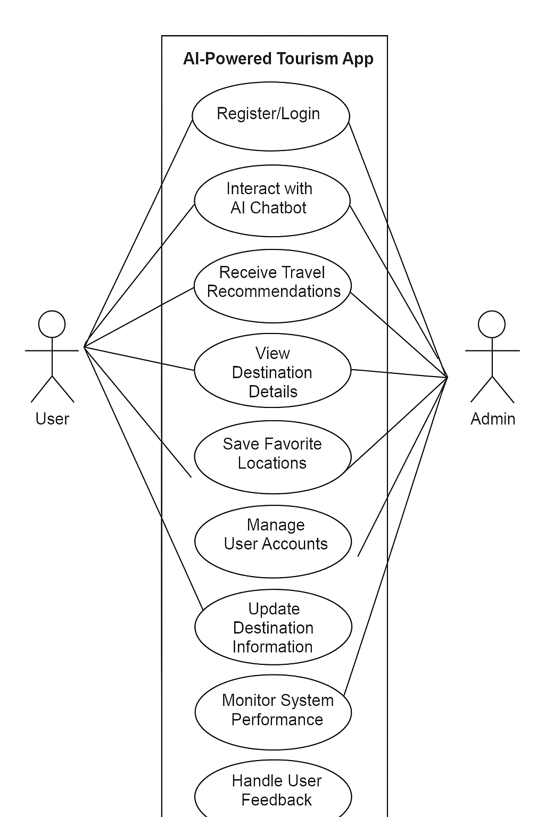

* + 1. **List of Actors**

|  |  |
| --- | --- |
| Actor | Role and Use Cases |
| Tourist/User | Searches for destinations, sets preferences, views recommendations, books itineraries, and provides feedback. |
| Administrator | Manages user accounts, monitors system performance, and updates travel information in the app. |
| Tour Operator | Provides details on tours, offers, and packages; collaborates with the app to update real-time availability. |
| Travel Guide | Shares detailed information about destinations, reviews itineraries, and provides recommendations. |
| Local Vendor | Lists services such as transportation, accommodations, or activities for tourists to book through the app. |
| Payment Gateway | Processes payments securely and confirms booking transactions. |
| Firebase System | Manages backend functionalities like database storage, user authentication, and real-time updates. |

## Non - Functional Requirements

* 1. **Performance Requirements**
* **Response Time:** The App must respond to user actions in a maximum of 5 seconds
* **Concurrent users:** Support 100 concurrent users without performance issue
* **Load Handling:** The platform must maintain performance levels under peak load conditions, with an uptime of 99.9%.

## Safety Requirements

Protect user data with secure storage and compliance with privacy laws.

Ensure safe financial transactions with encryption and secure gateways.

Provide accurate and verified travel information.

Use strong authentication to prevent unauthorized access.

Include emergency contact features for user safety.

## Security Requirements

###### Security Requirements

* **User Authentication:** Strong authentication mechanisms, including multi-factor authentication, should be in place to protect user accounts.
* **Data Encryption:** All user data should be encrypted both at rest and in transit using industry-standard encryption protocols.
* **Access Control:** Role-based access control should be implemented to ensure that only authorized users can access sensitive functions and data.

## Reliability Requirements

* **Availability:** The system should have an availability of 99.9%, ensuring that it is accessible to users almost all the time.
* **Fault Tolerance:** The platform should be designed to handle failures gracefully without affecting the overall system performance. Redundant systems should be in place to recover from failures quickly.

## Usability Requirements

Intuitive Interface: Easy-to-navigate design for all users.

User base Recommendations: driven by user-specific suggestions.

Quick Response: Fast loading and minimal interaction delays.

Consistent Design: Uniform interface across the app.

Feedback: Easy user feedback for continuous improvement.

## Supportability Requirements

* **Maintenance:** The system should be designed to allow for easy updates and maintenance without significant downtime.
* **Documentation:** Comprehensive technical documentation should be provided for developers, including API documentation, architecture diagrams, and setup guides.
* **Help and Support:** User support mechanisms, such as FAQs, help documentation, and customer support, should be readily available to assist users with any issues.

## User Documentation

#### Introduction

Welcome to AI Powered Tourism App, a comprehensive App-based platform designed to streamline your journey process. This user manual provides a detailed guide through the functionalities and features of our platform, ensuring you can utilize it to its full potential.

#### Getting Started

To begin using AI Powered Tourism App, you first need to create an account. Visit our homepage, click on the "Sign Up" button, and fill in the required details such as Name, Email, and Password. After creating your account, verify your email through the link sent to your inbox. Once verified, you can log in by clicking the "Login" button on the homepage and entering your registered email and password. After logging in, you'll be directed to your user dashboard where all the features of AI Powered Tourism App are accessible.

#### Features and Functionalities

The AI-powered Tourism App is designed to enhance the travel experience by leveraging and a user-friendly mobile interface. At its core, the app features an interactive chatbot that assists users in real-time by answering travel-related queries, suggesting destinations, and helping plan trips effectively. It includes a recommendation system that intelligently suggests tourist attractions based on user preferences, current location, and past activity. The app provides comprehensive information about historical sites and popular destinations, including descriptions, timings, and visiting tips. Built using React Native, the interface ensures smooth performance across Android devices, while Firebase integration enables secure authentication, real-time data management, and cloud-based storage. Users can also access and customize pre-made tour plan templates, save favorite places, and view previously explored locations. Additionally, selected data such as saved plans and favorite spots remain accessible offline, ensuring usability even in low-connectivity areas.

#### User Interface Overview

The AI-powered Tourism App features a clean, intuitive interface designed for easy navigation. The home screen provides quick access to the chatbot, destination recommendations, and saved travel plans. A bottom navigation bar ensures seamless switching between Home, Explore, Saved, and Profile sections. The design maintains a consistent layout and color scheme, with responsive buttons and familiar chat-style interactions. Overall, the UI is user-friendly, visually appealing, and optimized for a smooth travel planning experience.

#### User Account Management

Users can easily create, update, or delete their accounts. The app supports secure login and logout, profile editing, and password reset. User data, including preferences and saved destinations, is securely stored and synced across sessions for a personalized experience.

#### Integrations and API Usage

AI Powered Tourism App offers API access for integration with other systems. Detailed API documentation is available to guide you through the implementation process, allowing seamless integration with your existing tools and workflows.

#### FAQs and Customer Support

For common questions and troubleshooting steps, visit the FAQs section. If you need additional assistance, our customer support team is available via email at [support@aipoweredtourism.com](mailto:support@aipoweredtourism.com) on our website.

#### Glossary and Legal Information

The Glossary section provides definitions of key terms and abbreviations used throughout the platform. Additionally, our Legal and Privacy section outlines the terms of service, privacy policy, and data usage guidelines to help you understand your rights and responsibilities

## A3. Design Specifications 1 Introduction

* 1. **Purpose of Document**

This Software Requirements Specification (SRS) document outlines the functional and non-functional requirements that guide the development of the AI-Powered Tourism App. It serves as a guide for the development and testing of the system.

## Intended Audience

IDA App Design Document this document is useful for the development team, end users (travelers and tourists), project supervisors, Tester, marketing and sales teams With this, it makes sure that everyone is on the same page regarding the goals, features, and requirements of the AI-Powered Tourism App.

## Document Convention

• Headings: Arial, Bold, Size 16

• Subheadings: Arial, Bold, Size 14

• Body Text/Descriptions: Arial, Italic, Size 12

• Table Fields: Arial, Regular, Size 12, 10

## Project Overview

With this booming tourist industry in Pakistan, there is a demand for better solutions around traveling. The old-school process of trip planning and routing is rarely personalized or efficient. This is where the AI-Powered Tourism App comes in, utilizing the power to offer travelers user base recommendations, real-time information, and smooth navigation to their destination. In order to simplify travel planning and improve user engagement — and offer a modern solution for discovering and exploring. The app will change the way users travel, and will make it beyond easy.

## Scope

The AI-powered tourism application focused on enhancing user travel experiences through user base recommendations, travel planning, and real-time updates. The scope of this project explicitly defines what aspects will and will not be considered, along with key assumptions guiding system evolution.

**Not in Scope**

1. E-commerce – the app will not feature direct booking or purchasing for flights, accommodation, or other travel-based services.

2. High level social networking: Our app won't allow using profile to create content, send messages, etc.

3. No live chat or customer service integration.

4. While the app will support offline access for some tools (such as cached maps and guides), full offline capabilities for all features are not in scope currently.

## Design Considerations

###### User Experience (UX)

* + **Intuitive Interface:** Clean, user-friendly design with easy navigation.
  + **Responsive Design:** Optimization for tablets, and mobile devices.

###### Performance

* + **Load Balancing:** Even traffic distribution to maintain performance.
  + **Caching:** Use of CDN and in-memory caches to reduce latency.

###### Security

* + **Data Encryption:** Encryption of data at rest and in transit.
  + **Regular Audits:** Conducting security audits and vulnerability assessments.

###### Integration

* + **API Integration:** RESTful APIs for third-party tool integration.
  + **AI Models:** Integration with GPT-4, DALL-E, and Whisper for advanced features.

###### Maintainability

* + **Modular Codebase:** Well-documented, modular design for easy maintenance.
  + **Automated Testing:** Unit, integration, and end-to-end testing for stability.

###### Data Management

* + **Database Design:** Efficient use of Firestore with proper indexing.
  + **Backup and Recovery:** Regular backup procedures for data protection.

###### User Support

* + **Help Center:** Comprehensive documentation and FAQs.
  + **Customer Support:** Multiple support channels (email & phone).

###### Cost Management

* + **Cost-Effective Solutions:** Affordable, high-quality services.
  + **Resource Optimization:** Monitoring and optimizing resource usage.

These considerations ensure the AI Powered Tourism App is scalable, secure, and user-friendly, offering a seamless experience.

## Assumptions and Dependencies

User Devices: We assume that some users with smartphones or tablets (running Android 10 or above).

Internet Connectivity: Users should have a stable internet connection (Wi-Fi, 4G, 5G) for the app functionalities.

APIs: If the application relies on APIs for real-time data (weather, flight information, local attractions, etc), those need to be reliable and always up.

Quality: Testing and evaluating features to ensure the highest user experience quality.

Firebase: Usage of Firebase to handle real-time database, user authentication services and other backend functionalities.

## Risks and Volatile Areas

The project entails inherent risks and volatile areas that require diligent management. Dependency on third-party APIs poses a risk of disruption due to changes in availability or terms, necessitating contingency plans. Data privacy and security are paramount, demanding strict compliance with regulations to mitigate legal and reputational risks. Scalability and performance must be continuously monitored and optimized to handle increasing loads and ensure optimal user experience. Technical complexity in integrating basics AI models presents challenges that require careful navigation to prevent system failures. Market competition necessitates constant innovation to stay ahead and retain user interest. User

adoption and retention hinge on intuitive design and responsive adaptation to evolving user needs. Additionally, API reliability is crucial, and any changes in their functionality must be promptly addressed. Moreover, navigating evolving regulatory landscapes demands ongoing compliance efforts to avoid penalties and legal complications.

* 1. **System Level Architecture**

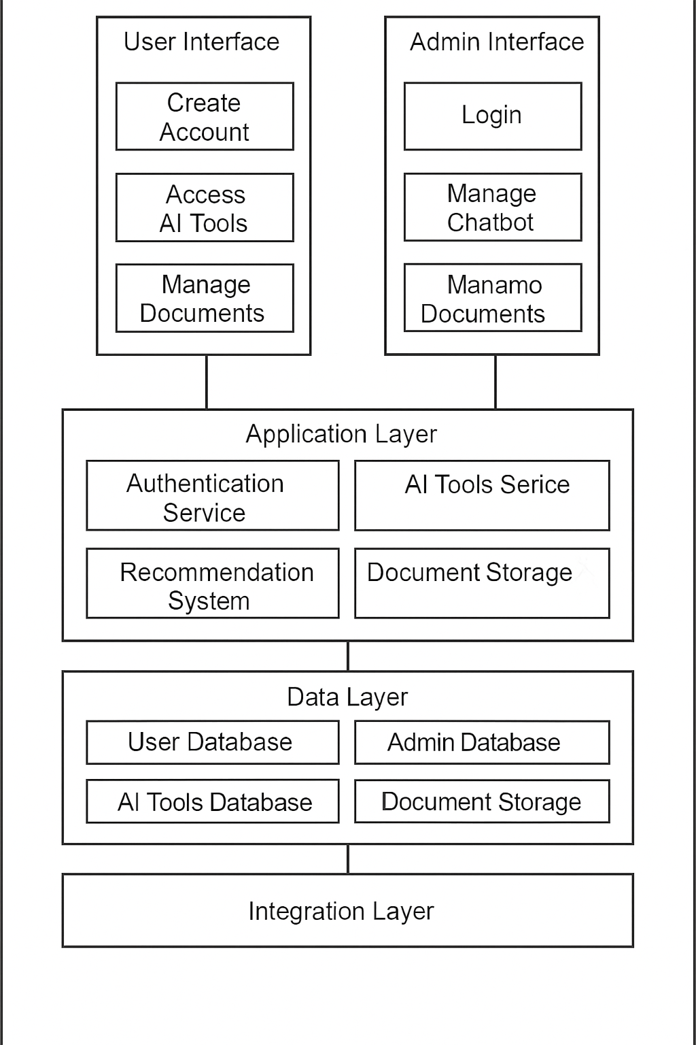

* 1. **Software Architecture**



1. **Design Strategy**

The design strategy for the AI Powered Tourism App centers on modularity, scalability, and adaptability to facilitate future system extension and enhancement. The system architecture employs a layered approach, separating concerns such as presentation, business logic, and data access. This promotes system reuse and enables seamless integration of new features or modules without affecting existing functionality. The user interface follows modern paradigms, prioritizing simplicity, intuitiveness, and responsiveness to enhance user experience across devices. Data management strategies focus on efficient storage, distribution, and persistence, leveraging scalable databases and cloud services to accommodate growing content volumes. Concurrency and synchronization mechanisms are employed to ensure data consistency and performance under concurrent user access. Trade-offs may include increased development complexity and resource requirements, but these are outweighed by the long-term benefits of a flexible and robust system architecture.

1. **Detailed System Design**
   1. **Design Class Diagram**



## Database Design

* + 1. **ER Diagram**

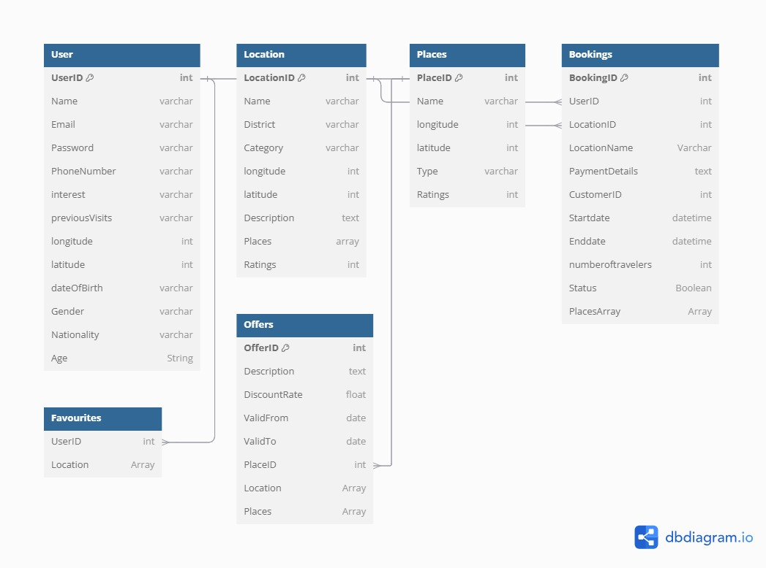

* + 1. **Sequence Diagram**

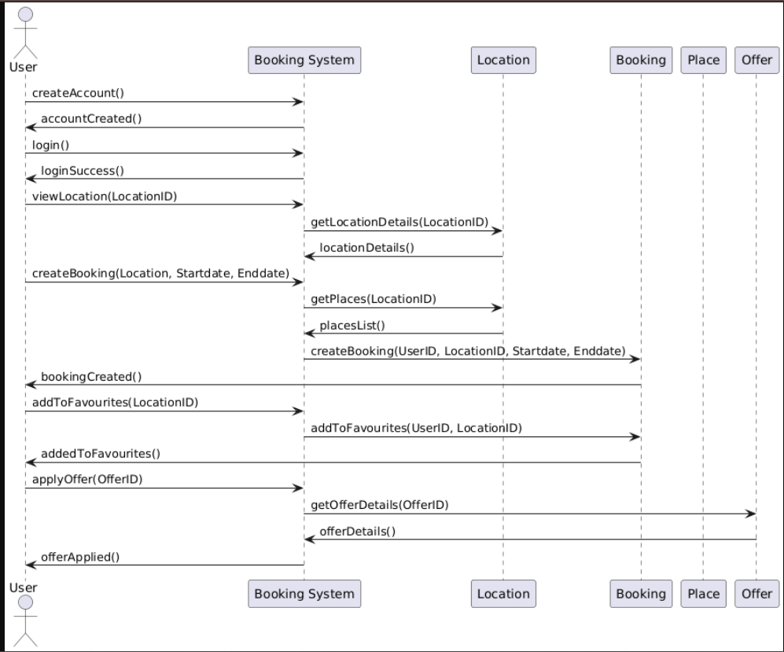

* + 1. **State Diagram**



## GUI Design

## A4. Other Technical Details Test Case Document

This chapter covers all tests performed in the system and the most important

## Black Box Testing:

##### TEST CASE 1: Login Functionality

|  |  |  |  |  |  |
| --- | --- | --- | --- | --- | --- |
| Test Case  ID | Description | Input Data | Expected  Outcome | Actual  Output | Pass/Fail |
| TC-Login- 01 | Enter valid username and password | Valid username and password | Successful login, redirection to dashboard | Successful login, redirection to dashboard | Pass |
| TC-Login- 02 | Enter invalid username or password | Invalid username or password | Error message, no access  granted | Error message, no access  granted | Pass |
| TC-Login- 03 | Empty fields | Empty username and/or  password | Error message prompting  for input | Error message prompting  for input | Pass |

###### Checklist:

* Validate successful login with correct credentials.
* Ensure error message appears with incorrect credentials.
* Check prompt for input when fields are empty.

##### TEST CASE 2: User Registration Functionality

|  |  |  |  |  |  |
| --- | --- | --- | --- | --- | --- |
| Test Case ID | Description | Input Data | Expected  Outcome | Actual  Output | Pass/Fail |
| TC-Register- 01 | Complete registration form | Valid user details | Registration successful, confirmation  message | Registration successful, confirmation  message | Pass |
| TC-Register- 02 | Incomplete registration form | Missing required fields | Error message prompting for missing  fields | Error message prompting for missing  fields | Pass |
| TC-Register- 01 | Duplicate email | Email already registered | Error message about duplicate  email | Error message about duplicate  email | Pass |

###### Checklist

* Ensure successful registration with valid details.
* Validate error messages for incomplete forms.
* Check for error message on duplicate email.

##### TEST CASE 3: Admin Dashboard Access

|  |  |  |  |  |  |
| --- | --- | --- | --- | --- | --- |
| Test Case ID | Description | Input Data | Expected  Outcome | Actual  Output | Pass/Fail |
| TC-Admin-01 | Access dashboard as admin | Admin credentials | Admin dashboard displayed | Admin dashboard displayed | Pass |
| TC-Admin-02 | Access dashboard as regular  user | User credentials | Access denied message | Access denied message | Pass |
| TC-Admin-03 | Verify data integrity | Verify data integrity | Data  integrity maintained | Data  integrity maintained | Pass |

###### Checklist

* Verify admin dashboard access with admin credentials.
* Ensure access denial for regular users.
* Check data integrity for admin actions

## WHITE BOX TESTING:

1. Login Functionality

**Objective:** Ensure proper authentication flow and secure handling of user credentials.

###### Test Scenarios:

* + Validate correct handling of valid and invalid credentials.
  + Ensure password hashing before storage.
  + Verify session management and token generation.
  + Check for SQL injection vulnerabilities.

###### Test Cases:

* + **Test Case 1:** Enter valid username and password; expect successful login and redirection to dashboard.
  + **Test Case 2:** Enter invalid username or password; expect error message and no access granted.
  + **Test Case 3:** Check password encryption; ensure plaintext password is not stored.
  + **Test Case 4:** Attempt SQL injection in login form; expect error handling and secure response.

##### User Registration Functionality

**Objective:** Ensure accurate user data handling and secure storage.

###### Test Scenarios:

* + Validate mandatory fields are required.
  + Ensure email verification link is sent.
  + Check for secure storage of user data.

###### Test Cases:

* + **Test Case 1:** Fill registration form with valid data; expect confirmation email and user creation.
  + **Test Case 2:** Leave mandatory fields blank; expect error message.
  + **Test Case 3:** Verify email uniqueness; ensure duplicate emails are rejected.
  + **Test Case 4:** Check secure storage; ensure user data is stored with encryption.

##### Admin Dashboard Access

**Objective:** Ensure secure and correct access to admin functionalities.

###### Test Scenarios:

* + Validate user roles and permissions.
  + Ensure secure handling of admin data.

###### Test Cases:

* + **Test Case 1:** Log in as admin; expect access to admin dashboard and functionalities.
  + **Test Case 2:** Log in as regular user; expect no access to admin dashboard.
  + **Test Case 3:** Check data integrity; ensure admin data is securely handled and not accessible by regular users.

These white box test cases focus on internal code structure, logic, and secure handling of data to ensure the robustness and reliability of the AI Powered Tourism App.

## Interface Testing for AI Powered Tourism App

**Interface Testing** ensures that different modules or components of the system interact correctly. This involves verifying that data is passed correctly and responses are as expected. **Checklist:**

* + Verify data transfer between front-end and back-end.
  + Ensure proper API responses and error handling.
  + Validate integration with external AI services (e.g., GPT, DALL-E).
  + Confirm UI elements trigger appropriate back-end processes.
  + Test data persistence and retrieval from the database.

##### Test Case : TC-INT-01

**Interface**: Front-end <-> Back-end

**Description**: Submit login form

###### Steps:

1. Navigate to the login page.
2. Enter a valid username and password.
3. Click the "Login" button.

###### Expected Output:

* + Successful login message.
  + User data is displayed.

###### Actual Output:

* + Successful login message.
  + User data is displayed.

**Pass/Fail**: Pass

##### Test Case ID: TC-INT-02

**Interface**: Front-end <-> API

**Description**: AI Chatbot

###### Steps:

1. Navigate to the AI Chatbot page.
2. Enter a valid text prompt.
3. Click the "Generate" button.

###### Expected Output:

* + Generated outcomes from chatbot displayed.

###### Actual Output:

* + Generated Outcomes is displayed.

**Pass/Fail**: Pass

##### Test Case ID: TC-INT-03

**Interface**: Front-end <-> Database

**Description**: Save user settings

###### Steps:

1. Navigate to the user settings page.
2. Enter new user settings data.
3. Click the "Save" button.

###### Expected Output:

* + Data saved confirmation message.

**Actual Output**: Data saved confirmation message.

**Pass/Fail**: Pass

##### Test Case ID: TC-INT-04

**Interface**: Back-end <-> AI API

**Description**: Recommendation system

###### Steps:

1. Send a request to the Recommendation system API with a valid prompt.
2. Wait for the API response.

###### Expected Output:

* + Recommendation system URL is received.

###### Actual Output:

* + Recommendation system Result is received.

**Pass/Fail**: Pass

These step-based test cases ensure that the interfaces within the AI Powered Tourism App function correctly and efficiently.

## INTEGRATING TESTING

Integration testing is a type of testing where software modules are integrated logically and are tested as a group. Software projects mostly contain multiple modules that are collectively combined together in components and are coded by different programmers. The purpose for integration testing is to identify the defects in the interaction between software modules when they are integrated. We will follow the big bang approach as it is convenient for small systems as in this approach all the components are integrated simultaneously, and testing is done as a whole system.

|  |  |  |  |  |
| --- | --- | --- | --- | --- |
| Test Case ID | Description | Expected  Outcome | Actual  Output | Pass/Fail |
| ITC-001 | Test user login and dashboard access | User is redirected to the dashboard and dashboard data is displayed  correctly | User is redirected to the dashboard, and data is displayed correctly | Pass |
| ITC-002 | AI Chatbot | Generated  Prompt displayed | Prompt generated, displayed | Pass |
|  |  | saved to the  database successfully | and saved successfully |  |
| ITC-003 | Plain Trip and display | Plain Trip is displayed correctly on  the page | Trip generated and displayed correctly | Pass |
| ITC-004 | Recommendation System | Recommendation System suggest previous history | Access Previous History | Pass |

## CONCLUSION:

The testing phase for the AI Powered Tourism App project has been meticulously executed to ensure the platform's functionality, performance, and reliability. Our comprehensive testing strategy included white-box testing, black-box testing, and integration testing, covering critical aspects of the system.

**White-box Testing:** In-depth testing of the internal structures and workings of the application revealed robust code integrity and effective error handling. The test cases focused on the logical flow, control structures, and data flow, ensuring the system components performed as intended under various conditions.

**Black-box Testing:** We conducted extensive black-box testing to validate the system's outputs against expected results. This testing approach ensured that the user interface, functionalities, and user experience met the requirements. The test cases verified the correct generation, display, and saving of content, as well as seamless user interactions across different modules.

**Integration Testing:** Integration tests were carried out to confirm the smooth interaction between different components of the system. The tests verified that user actions, such as logging in, solve user queries from chatbot were successfully integrated, providing a cohesive user experience.

###### Key Results:

* + **User Login and Dashboard:** The user login functionality was successfully integrated, with the dashboard displaying accurate data.
  + **Chatbot:** Solve user queries and saving to the database worked seamlessly.
  + **Recommendation System:** The Recommendation system feature performed as expected, displaying previous history correctly.

Overall, the testing outcomes indicate that the AI Powered Tourism App platform is robust, reliable, and ready for deployment. The successful integration of various functionalities ensures a smooth and efficient user experience. The adherence to rigorous testing standards has significantly minimized the risk of system failures, providing a high-quality, user-centric platform. Future maintenance and enhancements will be informed by the insights gained during this testing phase, ensuring the platform continues to meet users' needs effectively.

## UI/UX Details

**Home Page:**

Designed and implemented an engaging and informative home page that provides users with an introduction to the AI Powered Tourism App.



**Login/Sign Up**



## Registration Screen



**User Dashboard:**

Developed a user dashboard where registered users can log in, manage their accounts, and access various functionalities seamlessly





**Admin Dashboard:**



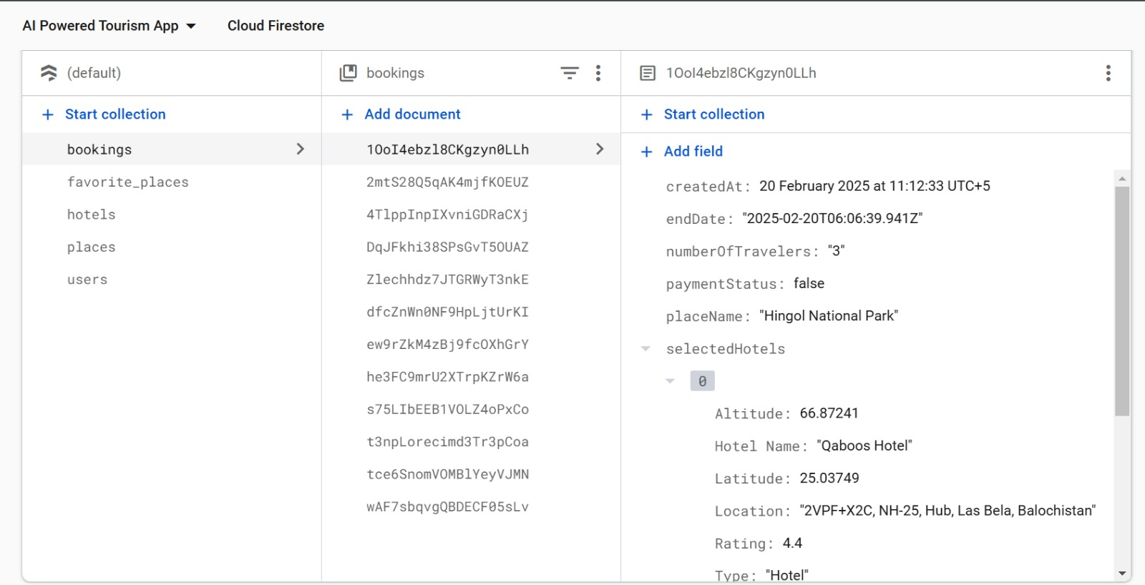

**Chatbot**

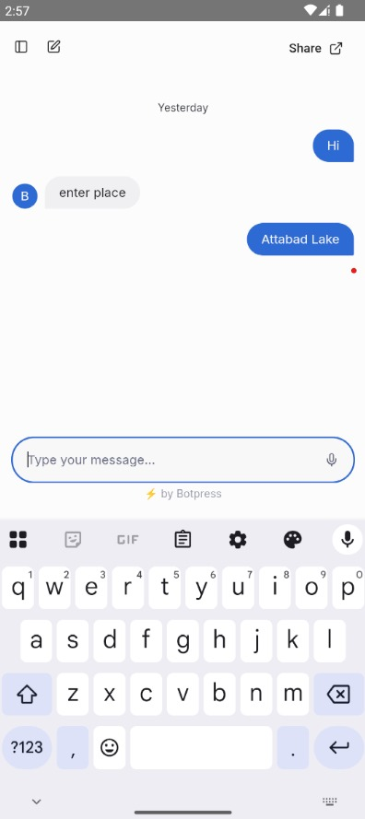

**Create your trip**

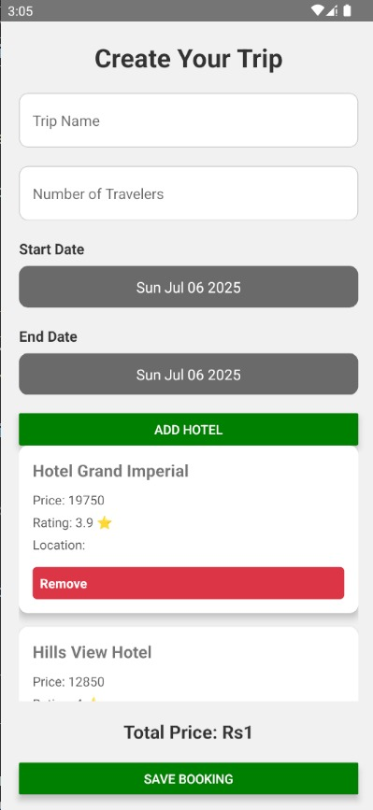

**Payment Method**

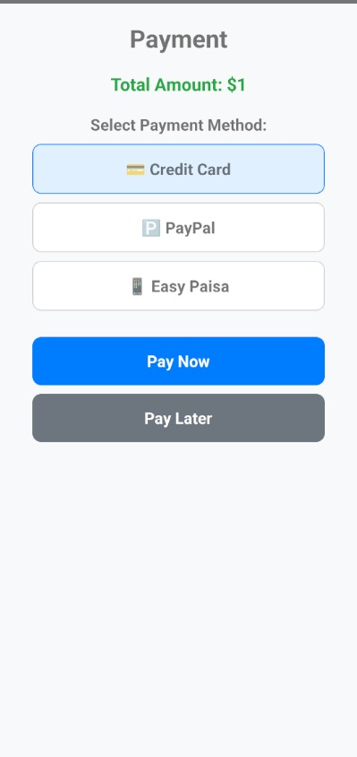

**Coding Standards**

## Introduction

The purpose of this coding standard document is to establish guidelines and best practices for writing code for the AI Powered Tourism App project. These standards aim to ensure code quality, maintainability, and consistency across the development team.

## Code Formatting:

* + Employ four spaces for indentation.
  + Keep lines under 100 characters in length
  + Position opening braces on the same line as control statements.
  + Maintain a single space after commas and operators.
  + Incorporate spaces after keywords and function names.

## Naming Conventions:

* + Utilize meaningful names for variables and functions (camelCase for variables, Pascal Case for functions).
  + Employ uppercase with underscores for constants.
  + Adhere to Pascal Case for class names and camelCase for object instances.

## Comments:

* + Include inline comments for complex logic or non-obvious code.
  + Employ block comments to elucidate functions or code sections.

## Error Handling:

* + Implement proper error handling mechanisms such as try-catch blocks and provide meaningful error messages.

## File Organization:

* + Organize code files logically within a directory structure.
  + Employ descriptive filenames reflecting the file's purpose.

## Version Control:

* + Make use of Git or other version control systems for code management.

## Performance:

* + Optimize code for efficiency by avoiding redundant calculations and selecting suitable data structures.

## Security:

* + Adhere to secure coding practices to mitigate common vulnerabilities.

## Review and Testing:

Conduct code reviews and comprehensive testing to ensure functionality and accuracy.

## Conclusion:

These coding standards guarantee a well-structured, readable, and maintainable codebase for the successful development of the AI Powered Tourism App.

## A5. Flyer & Poster Design

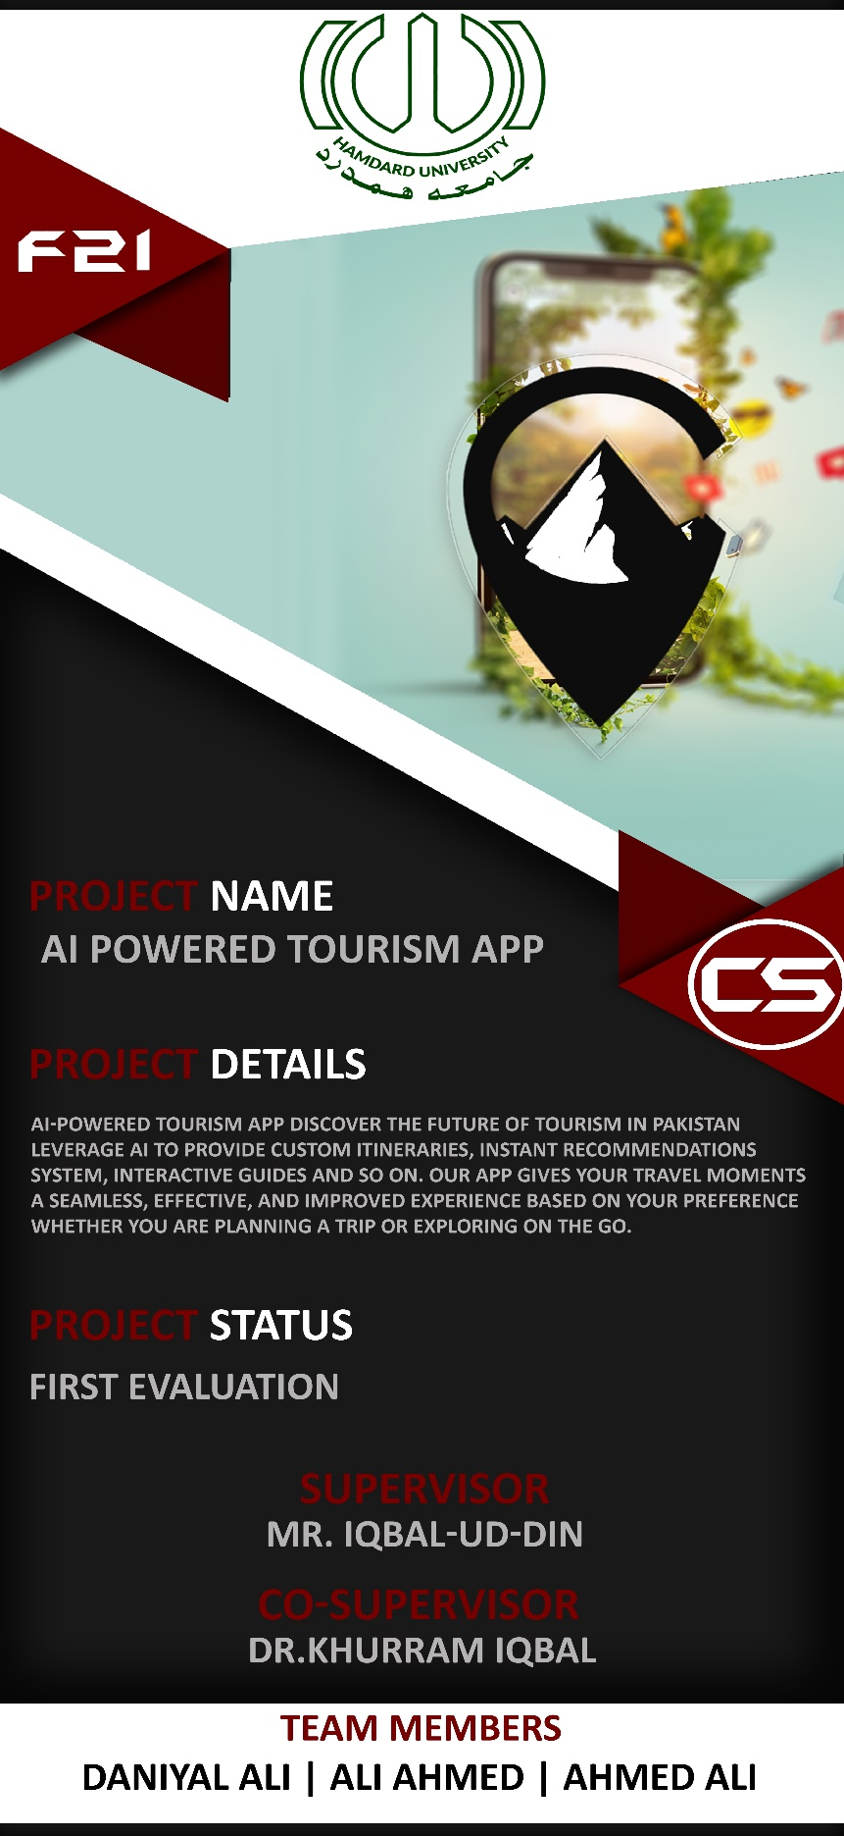

**A6. Copy of Evaluation Comments**

Comments by Jury for Project – I End Semester Evaluation

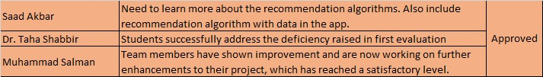

Comments by Jury for Project – II End Semester Evaluation

**Not yet!**

## 1st Meeting

**A7. Meetings’ Minutes**

## Minutes of Meeting

Meeting Date: 20/02/2025

Meeting Location: Faculty Room

Meeting Time: 10:00

### Project Title: AI Powered Tourism App

### Project Code: FYP-002/FL-24

##### List of Participants

|  |  |
| --- | --- |
| **Name** | **Project Role** |
| Daniyal Ali | Frontend, Backend |
| Ali Ahmed | Frontend, Documentations |
| Ahmed Ali | Backend, Database |

1. **Meeting Agenda**
   * Gather Information about Recommendation System.

##### Agenda Points discussed in meeting

* + Choosing Algorithm
  + Review of completed deliverables.

##### Next Meeting for this project

* + 06-March-2025 on same place

## 2nd Meeting

## Minutes of Meeting

Meeting Date: 06/03/2025 Meeting Location: Faculty Room

Meeting Time: 10:00

### Project Title: AI Powered Tourism App

### Project Code: FYP-002/FL-24

##### List of Participants

|  |  |
| --- | --- |
| **Name** | **Project Role** |
| Daniyal Ali | Frontend, Backend |
| Ali Ahmed | Frontend, Documentations |
| Ahmed Ali | Backend, Database |

1. **Meeting Agenda**
   * Chatbot Structure Finalization

##### Agenda Points discussed in meeting

* + Finalization of Chatbot
  + Gather Data for chatbot

##### Next Meeting for this project

* + 20-March-2025 on same place

## 3rd Meeting

**Minutes of Meeting** Meeting Date: 20/03/2025 Meeting Location: Faculty Room

Meeting Time: 10:00

### Project Title: AI Powered Tourism App

### Project Code: FYP-002/FL-24

##### List of Participants

|  |  |
| --- | --- |
| **Name** | **Project Role** |
| Daniyal Ali | Frontend, Backend |
| Ali Ahmed | Frontend, Documentations |
| Ahmed Ali | Backend, Database |

1. **Meeting Agenda**
   * Working on Chatbot

##### Agenda Points discussed in meeting

* + Train Data for chatbot
  + Fix error

##### Next Meeting for this project

* + 09-April-2025 on same place

## 4th Meeting

**Minutes of Meeting** Meeting Date: 09/04/2025 Meeting Location: Faculty Room

Meeting Time: 10:00

### Project Title: AI Powered Tourism App

### Project Code: FYP-002/FL-24

##### List of Participants

|  |  |
| --- | --- |
| **Name** | **Project Role** |
| Daniyal Ali | Frontend, Backend |
| Ali Ahmed | Frontend, Documentations |
| Ahmed Ali | Backend, Database |

1. **Meeting Agenda**
   * Testing Chatbot and getting data

##### Agenda Points discussed in meeting

* + Make chatbot data efficient

##### Next Meeting for this project

* + 17-April-2025 On same place

## 5th Meeting

**Minutes of Meeting** Meeting Date: 17/04/2025 Meeting Location: Faculty Room

Meeting Time: 10:00

### Project Title: AI Powered Tourism App

### Project Code: FYP-002/FL-24

##### List of Participants

|  |  |
| --- | --- |
| **Name** | **Project Role** |
| Daniyal Ali | Frontend, Backend |
| Ali Ahmed | Frontend, Documentations |
| Ahmed Ali | Backend, Database |

1. **Meeting Agenda**
   * Working on Recommendation System.

##### Agenda Points discussed in meeting

* + Final Selection of Algorithm for recommendation system.

##### Next Meeting for this project

* + 08-May-2025 On same place

## 6th Meeting

**Minutes of Meeting** Meeting Date: 08/05/2025 Meeting Location: Faculty Room

Meeting Time: 10:00

### Project Title: AI Powered Tourism App

### Project Code: FYP-002/FL-24

##### List of Participants

|  |  |
| --- | --- |
| **Name** | **Project Role** |
| Daniyal Ali | Frontend, Backend |
| Ali Ahmed | Frontend, Documentations |
| Ahmed Ali | Backend, Database |

1. **Meeting Agenda**
   * Implementation of recommendation system in our app

##### Agenda Points discussed in meeting

* + Integration of algorithm in our app.
  + Fix error or bugs

##### Next Meeting for this project

* + 22-May-2025 on same place

## 7th Meeting

**Minutes of Meeting** Meeting Date: 22/05/2025 Meeting Location: Faculty Room

Meeting Time: 10:00

### Project Title: AI Powered Tourism App

### Project Code: FYP-002/FL-24

##### List of Participants

|  |  |
| --- | --- |
| **Name** | **Project Role** |
| Daniyal Ali | Frontend, Backend |
| Ali Ahmed | Frontend, Documentations |
| Ahmed Ali | Backend, Database |

1. **Meeting Agenda**
   * Final Testing or fix the bugs.

##### Agenda Points discussed in meeting

* + Final Overview of App
  + Finalizing the app or convert into APK file

## A8. Project Progress

**FYP-II Fortnightly Sign-Up Sheet Fall 24**

